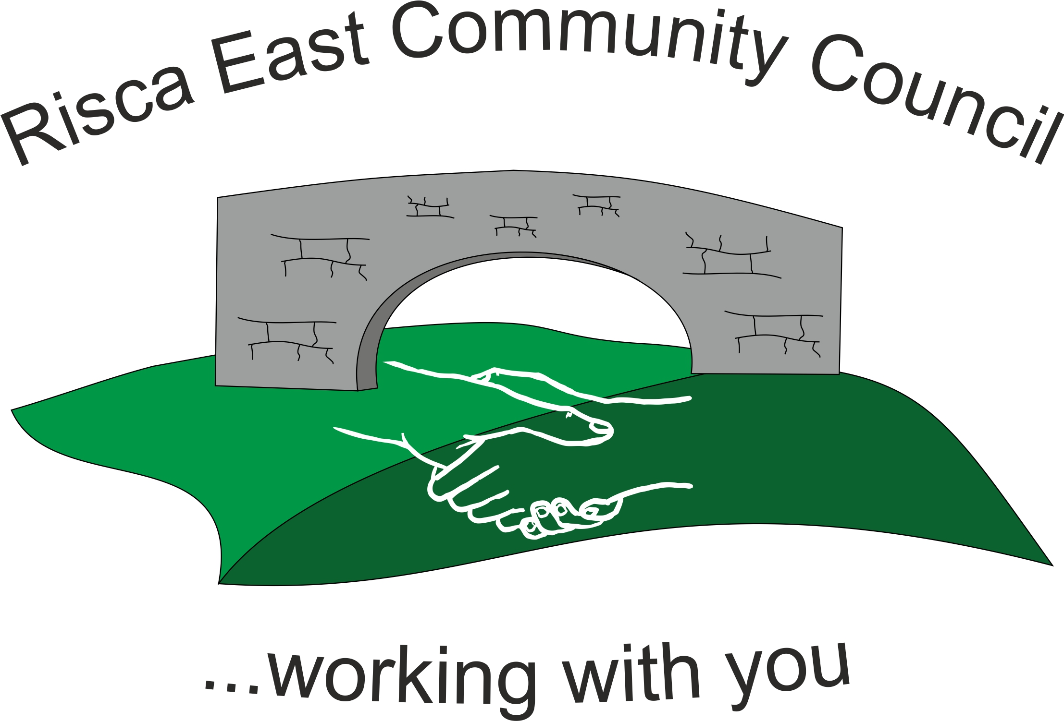 | Clerk/RFO Gwyn L. James  13, Cherry Tree Road  Pontllanfraith  Blackwood  Gwent  NP12 2PY  Tel. 07904 061754  www.riscaeastcc.org.uk  e-mail riscaeastcommunitycouncil@outlook.com
9th September 2019
Dear Councillor,
The next meeting of Risca East Community Council will take place on Thursday 19th September 2019 at 5:30 p.m. in the St. David’s Church, Thistle Way.
Agenda
- To sign the register and to receive apologies.
- To receive a report from the Police representatives.
- To receive representations from the public (15 minutes maximum time allowed).
- To receive and confirm the minutes of the meeting held 18th July 2019.
- Matters arising from the minutes
- To receive a financial report from the Clerk
- Correspondence
- To receive a report from County Borough Councillor Philippa Leonard
- To discuss local issues raised by Councillors
  - Ty Sign Ward
  - Pontymister Upper Ward
  - Trenewydd Ward
- To receive Planning notifications
- Christmas Lights – to discuss switching on the lights and organising a party.

