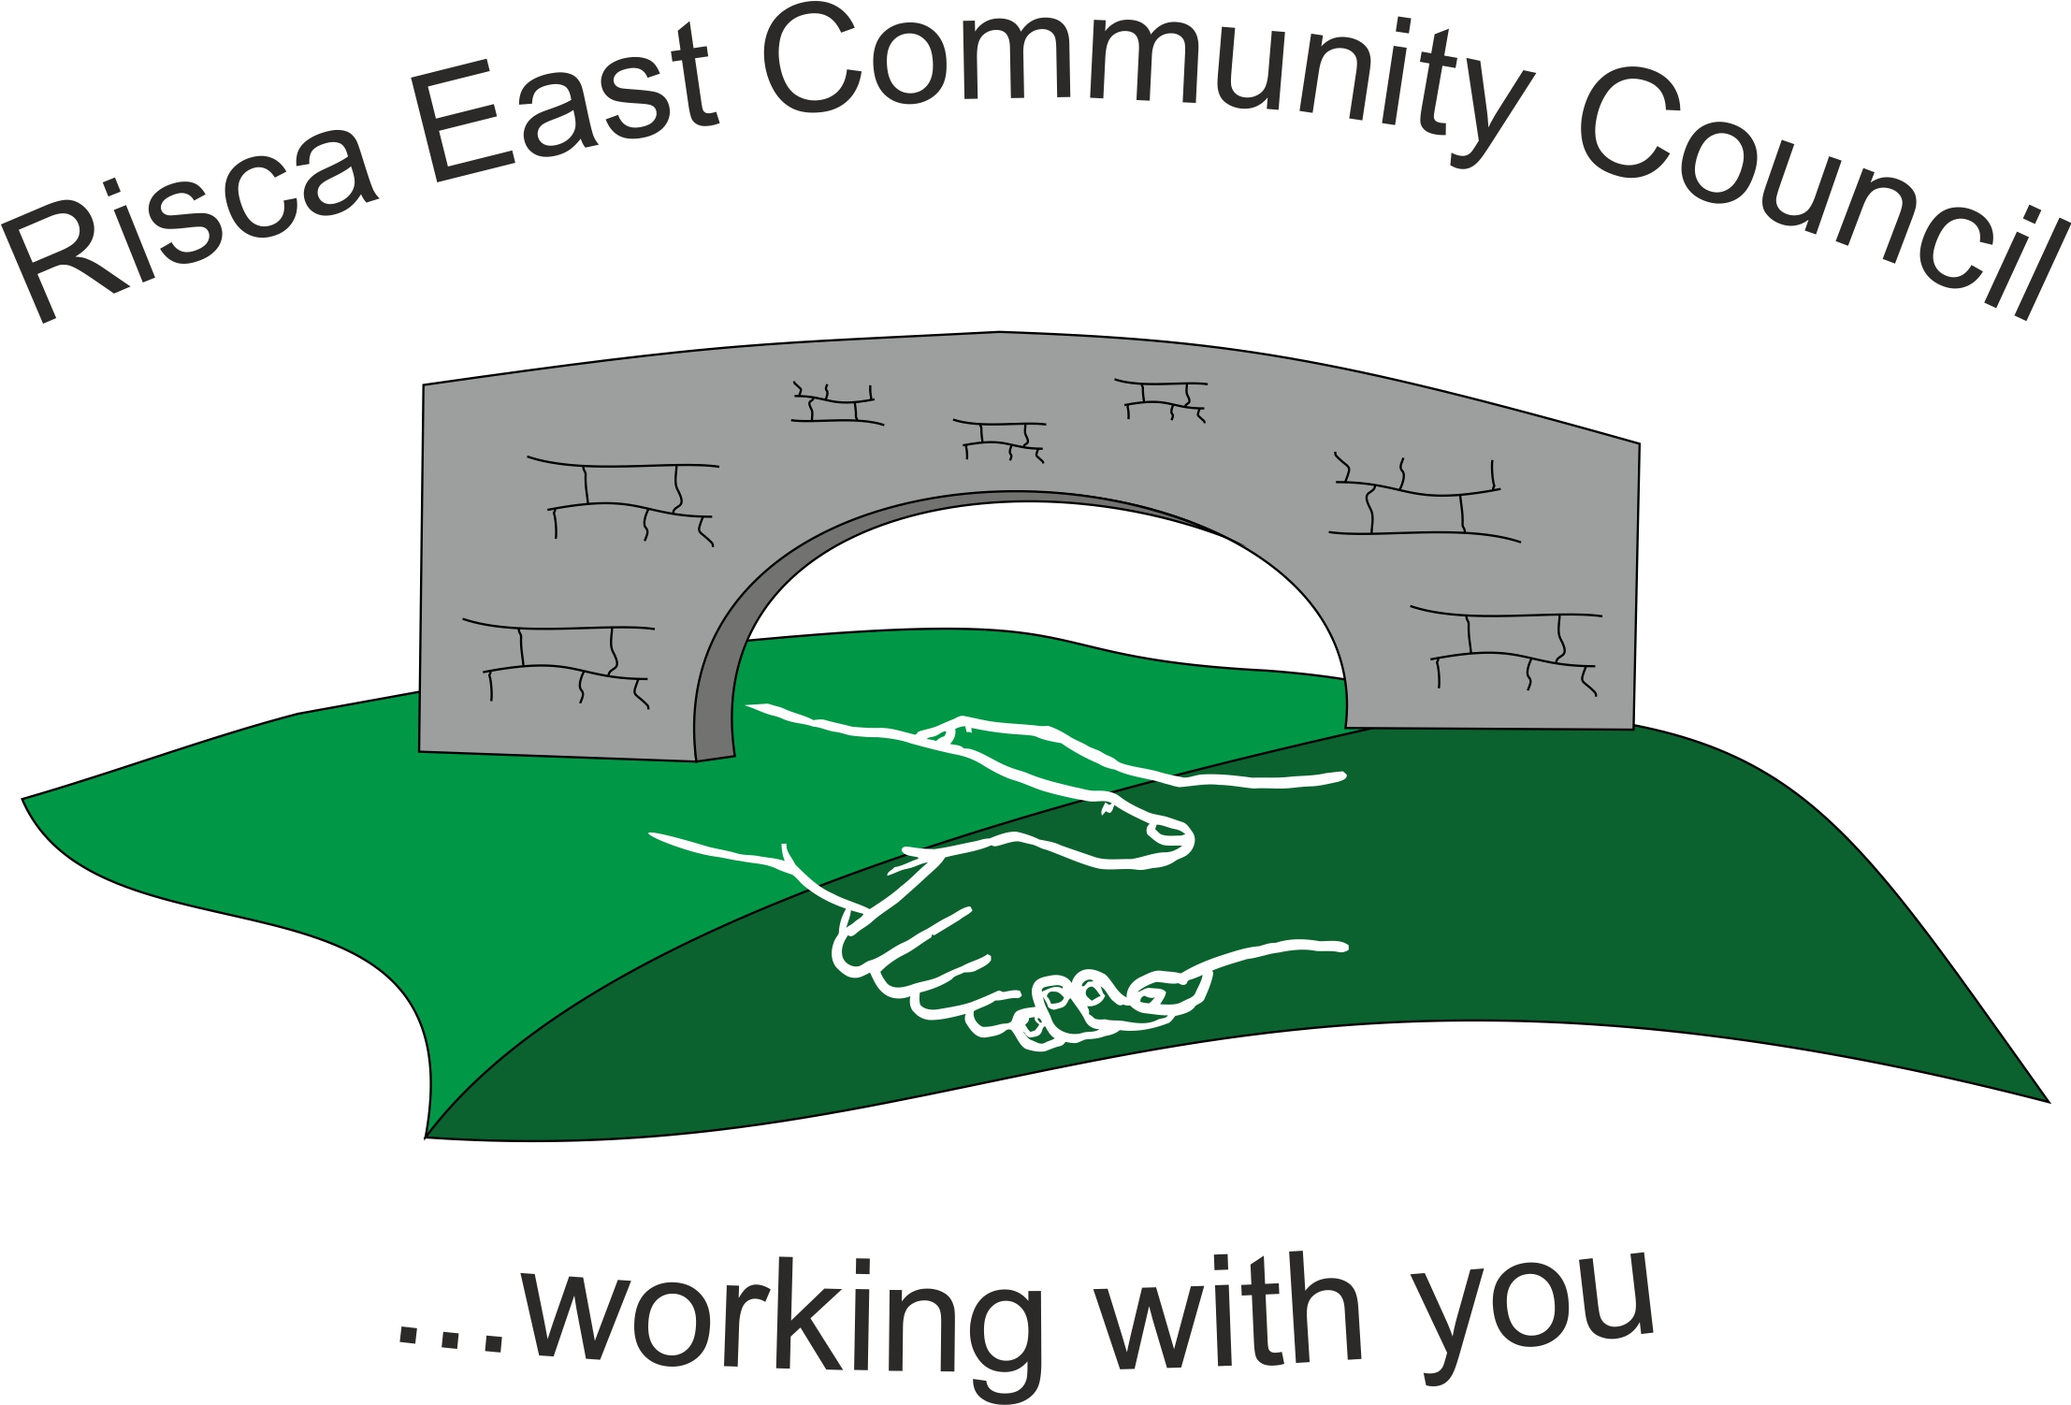
Funding Application Process (over £1000)

- Application must be formally requested in writing to the clerk of the community council. NO applications can be considered until an official application form with the relevant supporting information has been received by the clerk.
- Clerk shall send out the application form and guidelines form to the applicant/s
- Fully completed application form received with copies of the relevant supported information attached. (if the information such as confirmation of constitution, bank account, current financial status etc is not attached, the application is rejected until the information is received)
- Once a fully completed application form and all relevant information has been received, the application must be sent to all community councillors for their perusal at least 14 days prior to a community council meeting.
- At this stage, if any community councillor feels that they may have a personal or prejudicial interest in the application they must make it known by letting the clerk know. This must be completed in writing either via email or letter format.
- The community councillors (with the exception of any conflict of interest councillors) must then collate any questions that they wish to ask the applicant and send to the clerk. The clerk shall then send these questions to the applicant at least 7 days prior to a community council meeting.
- At the community council meeting and prior to discussion of the application any councillors that have revealed their interest may leave the meeting if its at this stage that they have to leave.
- The discussion with the applicant and councillors will take place with the chair asking the requested questions for answer. The councillors may want to elaborate once answers are given if relevant but should be kept to a minimum.
- Once happy that all information has been provided by both the applicant and councillors the applicant shall be asked to leave the meeting.
- At the point when a decision can be made of the application any councillor with conflict of interest will be asked to leave the meeting.
- Once decision is made the clerk will notify the applicant with details of the decision. If it is a funding rejected decision the clerk will write to let them know the reasons for the rejection.

Funding Application Form
- All applications can only be considered if this document is completed in full and all supporting copies of requested information is attached.
- Failure to complete will result in the application not being put forward to the councillors.
- The community council reserves the right to refuse an application for financial assistance.
- If funding is agreed by the community council, receipts must be produced corresponding with the funding application.
DATE………………………………….
Funding
Level of funding requested (over £1000) | £
Details of funding request
(please be as specific as possible)

Application Details
Name/Organisation
Address
Postcode
Contact Telephone
Contact name and position in organisation
Address (if Different)

Page 1

Income and Expenditure for the financial year ending 31st March 20…….

Income | £ | Expenditure | £
Surplus from previous year |  | Deficit from previous year
Membership Subscriptions |  | Rent/Rates
Other |  | Utilities
 |  | Other
Totals |  | Totals

Additional Information
How long has the organisation been going?
How many members do the organisation have?
How many under 16 members are there?
What % of members live in the Risca East Area?
What are the primary objectives of the organisation?
Have you received funding from anyone else to date? Please give details
What fundraising activities have you completed on your own behalf to date?
If national, please state involvement within Risca East community?
If you own or rent premises, please let us know the address?

Page 2

Essential Information requested;
DOCUMENT | YES | NO
BANK DETAILS ATTACHED
CONSTITUTION ATTACHED
TRUSTEES/MANAGEMENT | NAME | POSITION
1
2
3
4

I/We certify that the details given above and attached are correct and true
Signed by | Position
Print name | Date

For community council use only
Note | Qualification Yes/No | Date
Application Form
Added Documents
Sent Councillors
Received Questions Councillors
Business Interests
Questions sent Applicant
Meeting Applied
Funding Agreed
Funding Rejected

Page 3

