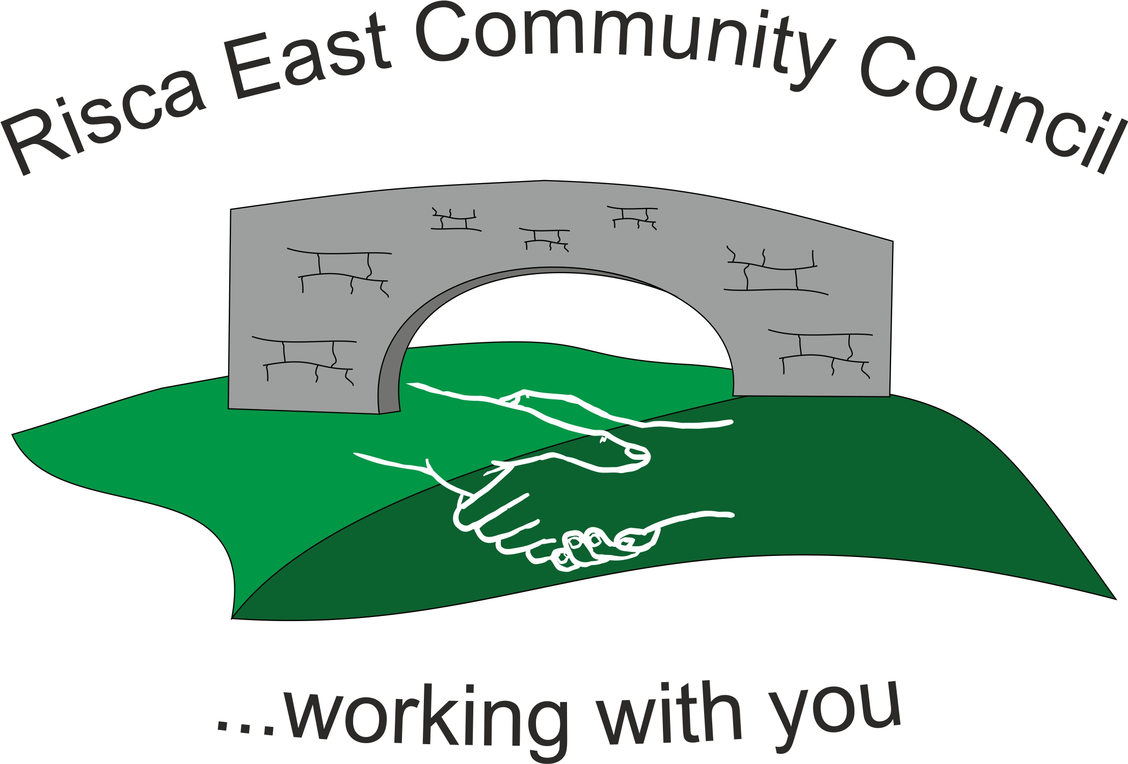
Smaller Grant Funding Application Process

- Application must be formally requested in writing to the clerk or in person at a monthly community council meeting.
- At this stage, if any community councillor feels that they may have a personal or prejudicial interest in the application they must make it known by letting the clerk know. This must be completed in writing either via email, letter format or in person at the point of the meeting in order for it to be officially recorded by the clerk.

Small Grant Funding Application Form
- The community council reserves the right to refuse an application for financial assistance.

DATE………………………………….
Funding
Level of funding requested (up to £1000) | £
Details of funding request
(please be as specific as possible)

Application Details
Name/Organisation
Address
Postcode
Contact Telephone
Contact name and position in organisation
Address (if Different)

Additional Information

Essential Information requested;
DOCUMENT | YES | NO
BANK DETAILS ATTACHED

I/We certify that the details given above and attached are correct and true
Signed by | Position
Print name | Date

For community council use only
Note | Qualification Yes/No | Date
Application Form
Added Documents
Funding Agreed
Funding Rejected – Reason

