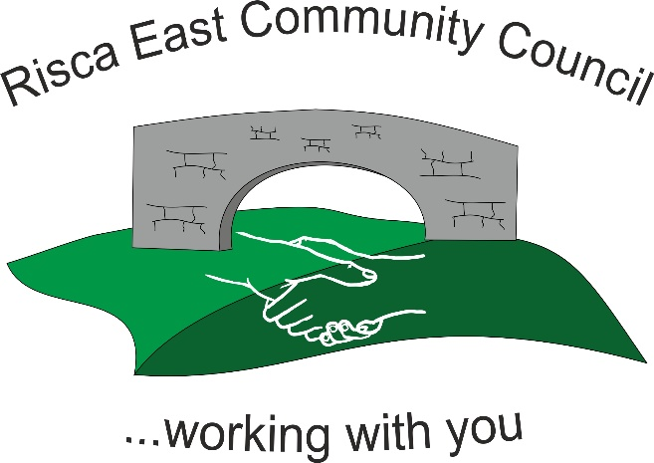 | Clerk/RFO Nicola Roberts.  Village Farm,  Manmoel, Blackwood, Caerphilly.  NP12 0RW.  Tel. 07904 061754.  www.riscaeastcc.org.uk  e-mail riscaeastcommunitycouncil@outlook.com

31 st | March 2022
28th | April 2022
26th | May 2022
23rd | June 2022
28th | July 2022
22nd | September 2022
27th | October 2022
24th | November 2022

