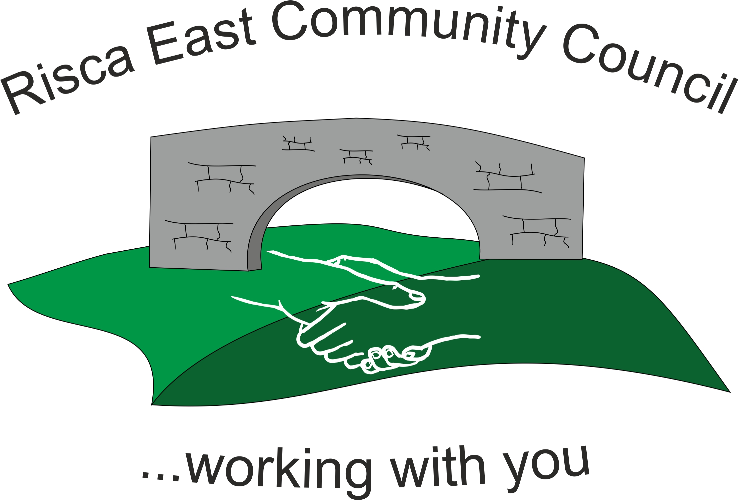 | Clerk/RFO Gwyn L. James  4, Blorenge View  Llanfoist  Abergavenny  NP7 9YB  Tel. 07904 061754  www.riscaeastcc.org.uk  e-mail riscaeastcommunitycouncil@outlook.com
7th April 2021
Dear Councillor,
The next meeting of Risca East Community Council will take place on Thursday 15th April 2021 at 7:00 p.m. using MSTeams.
Agenda
- To record attendance and receive apologies.
- To receive and confirm the minutes of the meeting held on 18th March 2021.
- Matters arising from the minutes
  - New Community Council notice board
  - Revised Grant Application Form and process
  - LDP update
  - Empowerment Find
- To receive a financial report from the Clerk
- Correspondence
- Items for discussion
  - Cllr Zoe Davies has requested the following items be discussed
    - Skate park
    - Anti-social behaviour
- To receive a report from County Borough Councillor Philippa Leonard
- To discuss local issues raised by Councillors
  - Ty Sign Ward
  - Pontymister Upper Ward
  - Trenewydd Ward
- To receive Planning notifications

