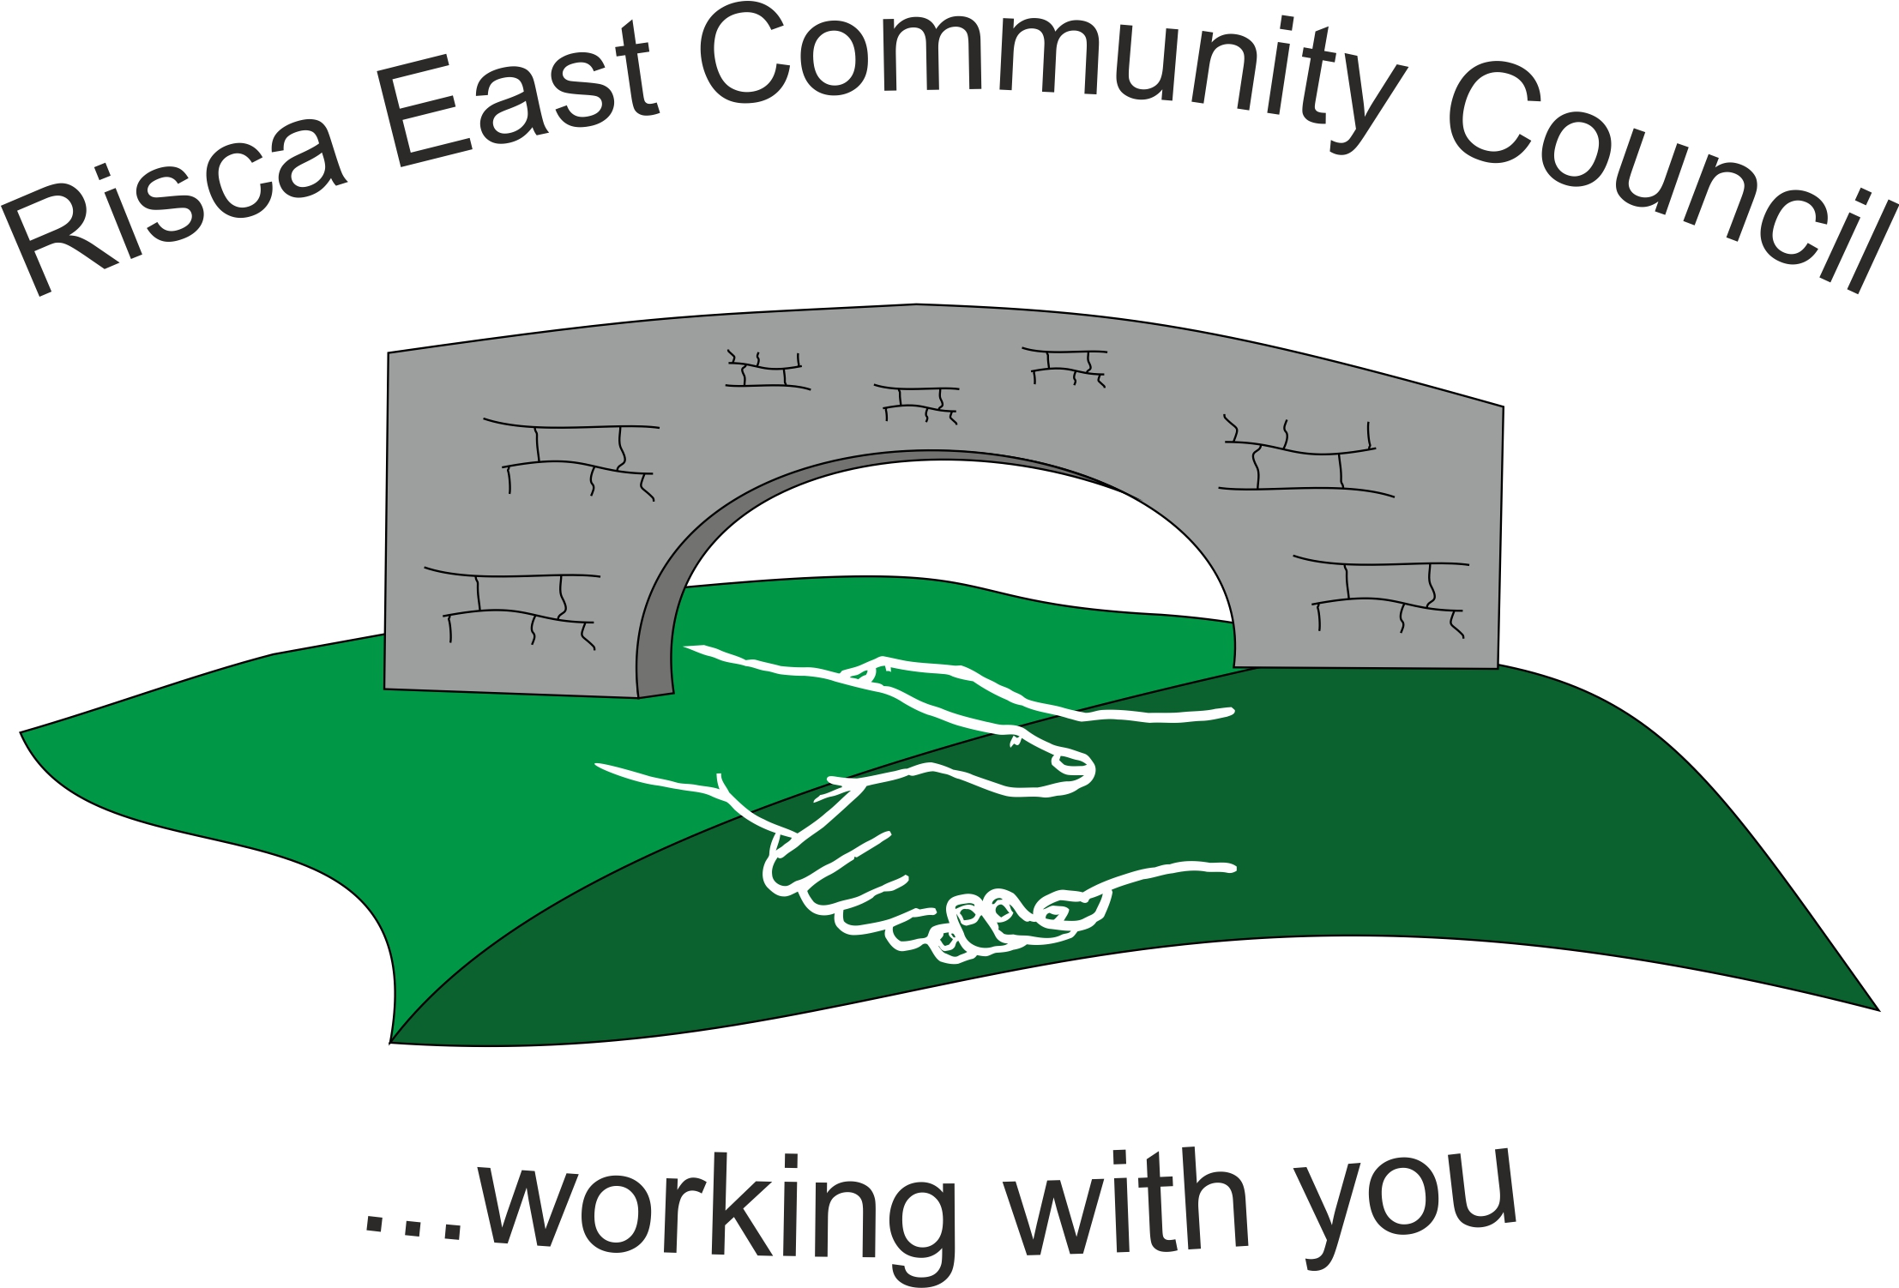 | Clerk/RFO Nicola Roberts  Village Farm  Manmoel  Blackwood  NP12 0RW  Tel. 07904 061754  www.riscaeastcc.org.uk  e-mail riscaeastcommunitycouncil@outlook.com
1031 Attendance and Apologies
Meeting started 18.27pm
To record attendance and receive apologies.
1031.1 Community Councillors present – Councillors Rosemary Creedy, Zoe Davies, Nigel George, Deb Crahart (remote), Christinne Thomas and Arianna Leonard and Philippa Leonard.
1031.2 The Committee were also joined by Guests Bernadette Martin and Amy Billings
1031.3 Apologies were received Cllr Rob Derravan.
.

1032 Minutes of the previous meeting
These were received as a true record Cllr Nigel Georget proposed and Philippa Leonard seconded that the minutes were correct.

1033 Matters arising from the minutes
- Web site maintenance and development - RC was unable to find a cheaper alternative to the current provider her recommendation was to keep with the current provider. It was noted that Darren Valley had a very user friendly website, NR to contact the clerk and to ask advice. Going forward NR to seek training on the website and training costs to be no more than £200. RC to chase the contact details and pass to NR.
- Christmas lights – Clerk to chase up exact lights that are broken so that replacement lights can be organised.

- Risca Directory - next issue is the May issue and Deb Crahart hasn’t been well therefore CT and RC will be writing this piece.

- Police representative – unfortunately the Police officer was unable to attend and this will be arranged for a future date.

- Item 1026.2 the Clerk to write to Mike Headington to ensure we have permission to install the bench and Tree for the Queens Jubilee.

1034 To receive the financial report from the Clerk
1034.1 The clerk ran through the report and the proposed expenditure was agreed.

1035 – Correspondance

1035.1 Clerk explained that a number of organisations had requested a small grant application form, but nothing had yet been received. Clerk to contact RBL – Steve Vesey to request the submission of the claim form so that it could be distributed for consideration.
1035.2 An email had been received regarding the new LDP plan that CCBC were in the process of consulting on. This would be sent out and the clerk will coordinate any responses.
1035.3 Email also received regarding renewing the pads for the defibrillator – clerk to determine the costs of replacement and seek approval from the committee.

1036 – Events – Queens Jubilee
1036.2 – the sub committee has made great progress Jubilee celebrations They updated the full committee about discussions to date. It was suggested that there will be a poem competition and a drawing competition. It was agreed that the opening ceremony will be 2 June 3pm. This will be mentioned in the Risca Directory. They were hoping to use the Argus to advertise the unveiling of the benches and tree. The sub Committee have been given a cap of £15,000 this will include the preparation and distribution of leaflets advertising the event. All Committee members agree this except for Cllr Nigel George who disagreed.

1037 – To receive the report from Councillor Arianna Leonard

1037.1 Parking update – There has been £400k allocated to deal with this issue. A feasibility study will be prepared.
1037.2 The Housing department are considering the land at the end of the Shops in order to expand the entrance to the car park. This will overcome the congestion around key times e.g. school pick ups.
1037.3 The CA sites now allow vans in with a permit – a V11 form will be needed as proof of ownership.
1037.4 CCBC have booked Channel View to hold surgeries for the public between 10am – 4pm. Appointments must be made in advance to discuss Housing benefits and Social and Health care. Telephone numbers are:
- 01443 873535 Housing Appointments
- 01443 866534 Social and Health care issues.
1037.5 For Polling Day the locations are Channel View, Risca Comprehensive, and there is a early voting centre for anyone in the Borough on 30/4/22.

1038 To discuss local issues raised by Councillors

- Ty Sign Ward – nothing to report

- Pontymister Upper Ward – nothing to report.

- Trenewydd - nothing to report.

1039 Planning Notifications
None to report.

1040 Any other business
1040.1 Cllr Rosemary Creedy will be resigning from the end of the next meeting, It is felt that new faces with new ideas need to be encouraged. Once Cllr Deb Crahart feels better, it was decided the Committee will meet to welcome new faces and say goodbye to the old faces. The Committee thanks Rosemary for her time and effort over the years.
1040.2 – Donatins to the war efforts was discussed, currently this is prohitied unless it is for the benefit of the Local Council area. Discussions at the next meeting will take place on support that can be given locally.

1030.3 – Date of next meeting 24th March 2022 at 6 pm to start at 6.30pm. Meeting closed at 7:05pm

Signed……………………………………………………….Chairman 10th February 2022

