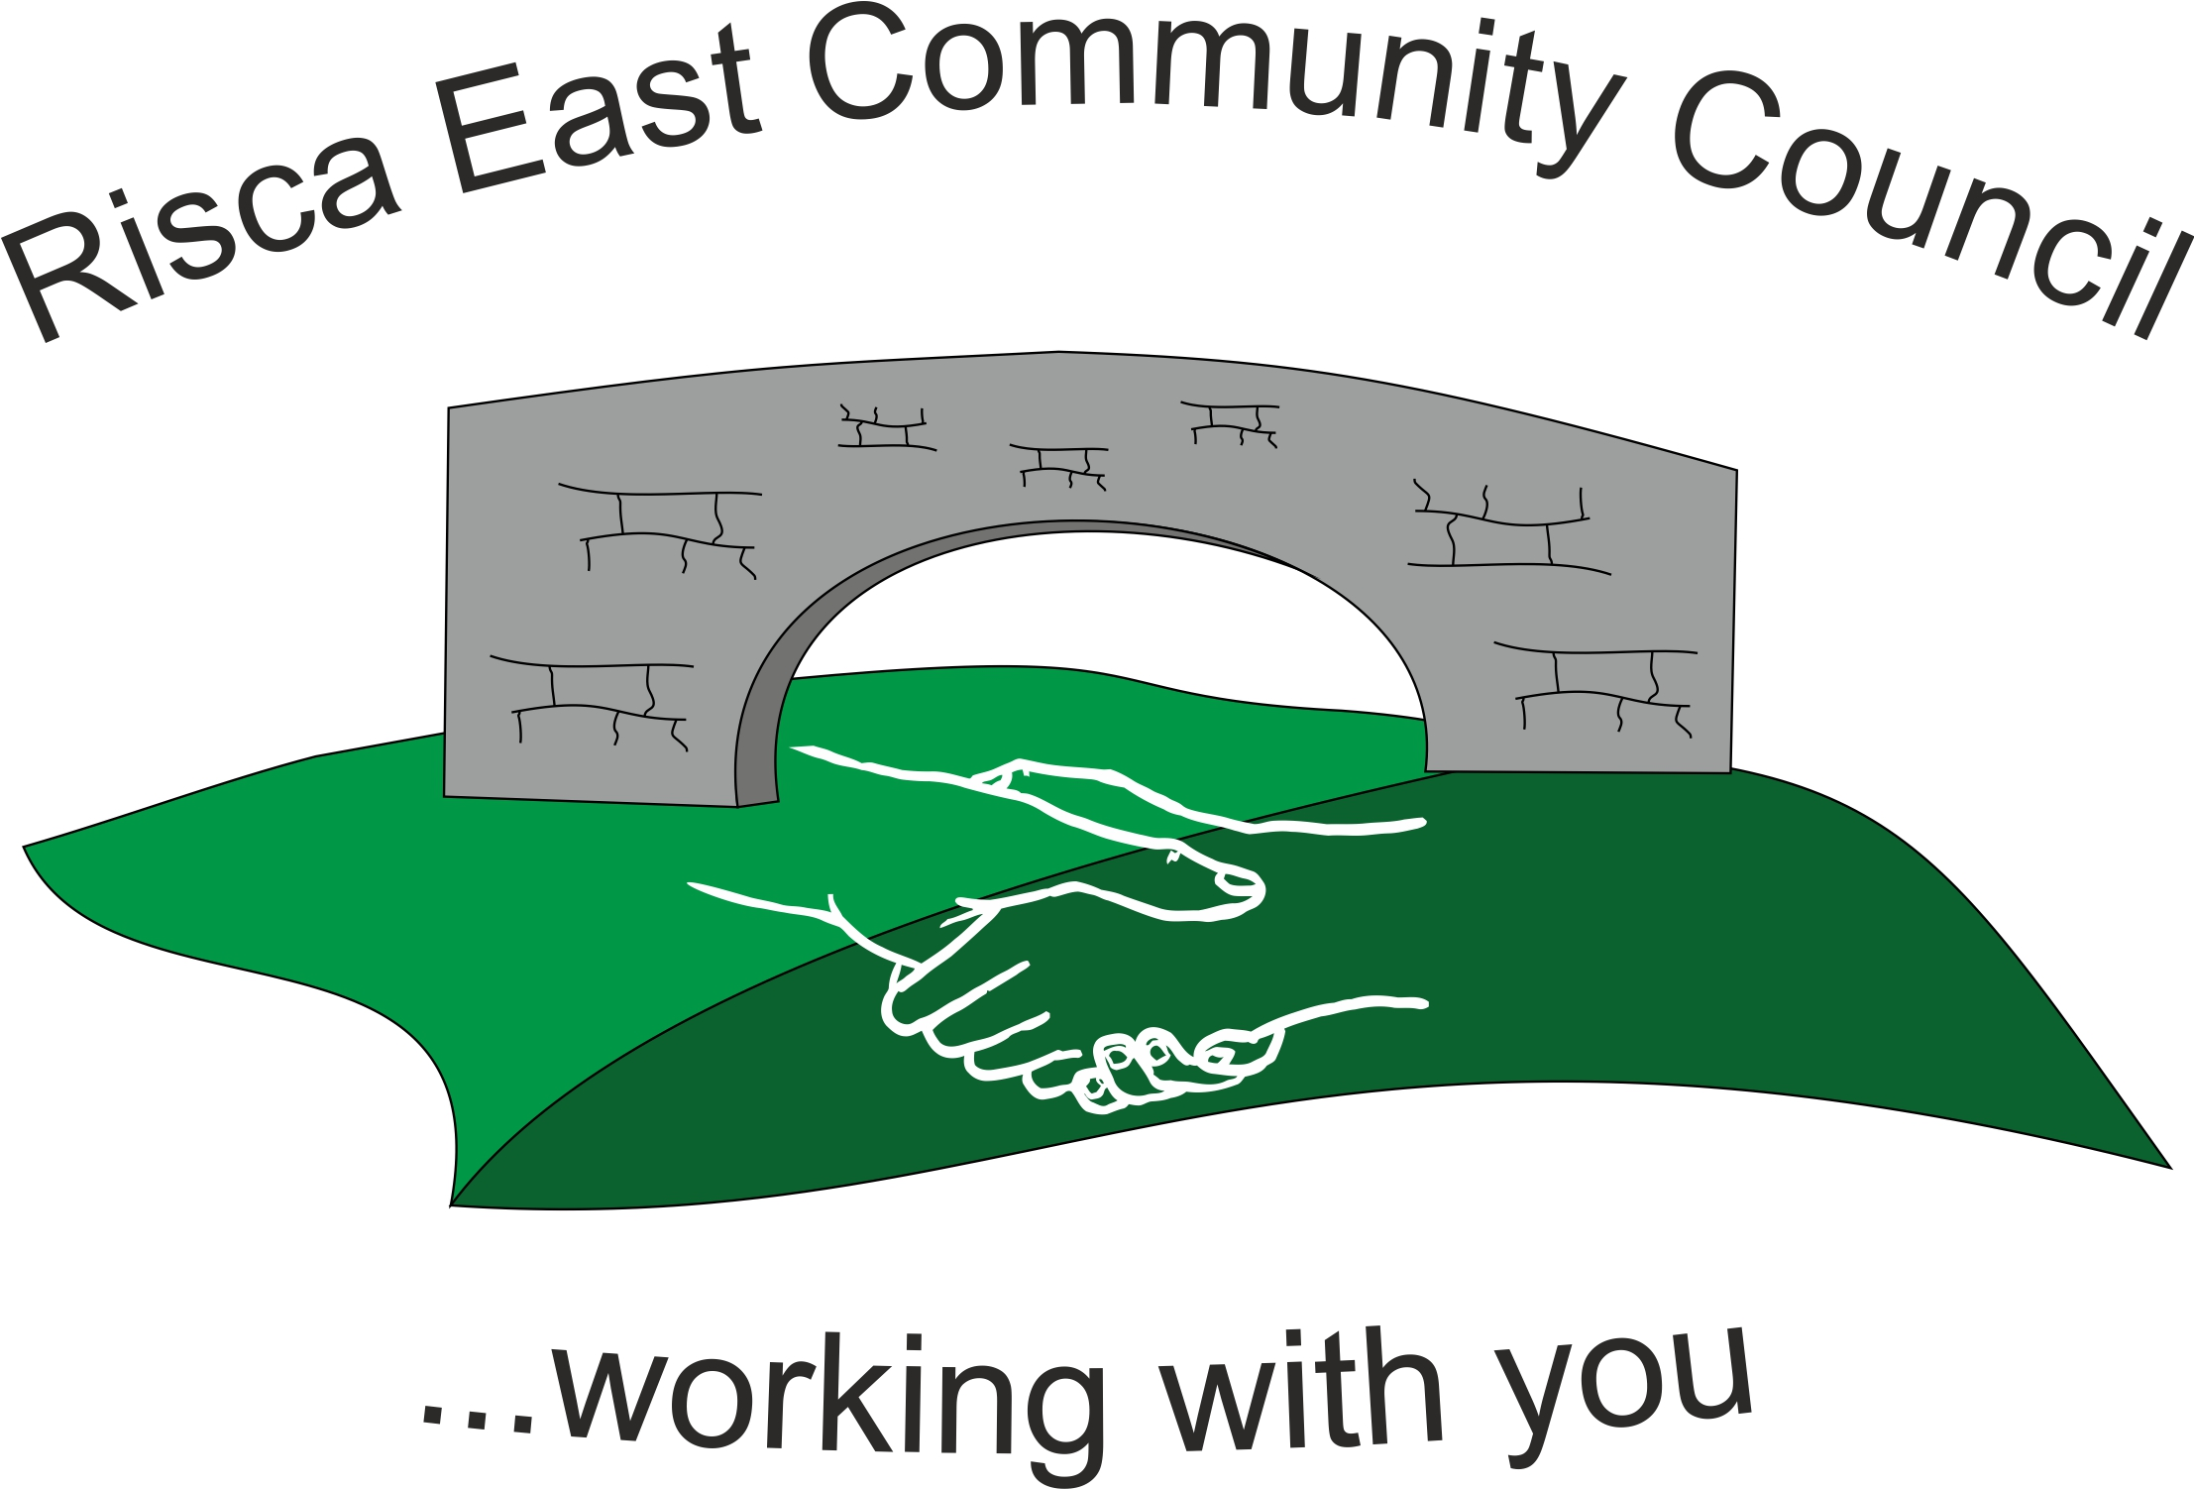 | Clerk/RFO Nicola Roberts  Village Farm  Manmoel  Blackwood  NP12 0RW  Tel. 07904 061754  www.riscaeastcc.org.uk  e-mail riscaeastcommunitycouncil@outlook.com
Minutes of the Annual General Meeting of Risca East Community Council held on Tuesday 24th May 2022 at 6 pm in the TLC in Tysign Risca.

24-5-22 Meeting started 18.05pm

1050 Attendance and Apologies
To record attendance and receive apologies.
1050.1 Community Councillors present – Councillors Zoe Davies, Nigel George, Christinne Thomas, Philippa Leonard, Bernadette Martin, Arrianna Leonard, Amy Billings and Brandon Ham.

1051 To Elect a Chairperson for the forth coming year
Cllr Chris Thomas proposed Cllr Zoe Davies and Cllr Phillippa Leonard proposed Cllr Arrianna Leonard. Votes were made and Councillor Zoe Davies was voted as Chair person for the forth coming year.

1052 To elect a Vice Chair for the forth coming year
Cllr Chris Thomas proposed Cllr Nigel Geroge and Cllr Phillippa Leonard proposed Cllr Arrianna Leonard. Voting was made and the Vice Chair for the forth coming year was Councillor Nigel George.

1053 To sign declaration of office by newly elected Chair Person
The acceptance was signed by the new Chair person and counter signed by the Clerk.

1054 Minutes of the previous meeting
Councillor Chris Thomas queried that the Chair allowance was not agreed at £250 as stipulated in the minutes and that it should have been £1,500 for 21-22. This was unanimously agreed and the amendment made.

1054.2 Advertising for the Council Vacancy
This would be sent to Cllr Chris Thomas who agreed that she would place this in the notice boards. It would also be placed on the Facebook page.

1055 To elect representatives on the following Committees:
1055.1 Caerphilly County Borough Council Town and Community Councils Joint Liaison Committee – Cllrs Nigel George, Zoe Davies, Arrianna Leonard and Chirs Thomas were elected.
1055.2 Ty Sign Primary School – Cllr Zoe Davies to contact the Chair of the Board of Governors to ask for Cllr Arrianna Leonard to be put forward as the LEA representative. Cllr Brandon Ham to be elected as the Community Governor.
1055.3 Risca Town Centre Management Committee – Cllrs Bernadette Martin and Chris Thomas
1055.4 One Voice Wales - Cllr Amy Billings
1055.5 A suggestion was made to have a joint Council with Risca Town – Cllrs Bernadette Martin, Chirs Thomas and Nigel George

1056 To decide upon the Chair person’s Allowance for 2022/23 in pursuance of the Local Government Act 1972
For 22/23 the Chair person’s allowance was set at £250. Should the expenses be much higher than this then the Committee reserved the right to review the amount of the allowance.

Meeting closed at 6:45 pm.

Signed……………………………………………………….Chairman 23rd June 2022

