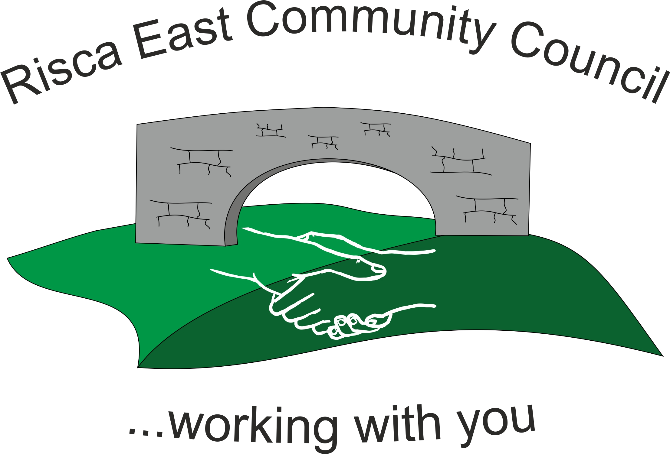 | Clerk/RFO Nicola Roberts  Village Farm  Manmoel  Blackwood  NP12 0RW  Tel. 07904 061754  www.riscaeastcc.org.uk  e-mail riscaeastcommunitycouncil@outlook.com
24-5-22 Meeting started 18.50pm

5/22/1 Attendance and Apologies
To record attendance and receive apologies.
5/22/1.1 Community Councillors present – Councillors Zoe Davies, Nigel George, Christinne Thomas, Bernadette Martin, Brandon Ham, Amy Billings, Philippa Leonard and Arrianna Leonard .
5/22/1.2 No apologies.

5/22/2 Minutes of the previous meeting
These were received as a true record Cllr Zoe Davies proposed and Cllr Phillippa Leonard seconded that the minutes were correct.

5/22/3 Matters arising from the minutes
- Web site maintenance and development –Cllr Brandon Ham explained that he has the necessary expertise to manage websites. It was agreed that he would help with bringing the website up to date. A new logo was discussed and agreed that the logo for the Jubilee leaflets would be used.
- Christmas lights – No movement on any catalogues for replacement lights.

- Risca Directory - It was established that the Directory did not reach all parts of the Community Council. It was agreed that Cllr Chris Thomas would contact the Directory and ask for 200 copies that could be placed in shops to distribute to wider households.

5/22/4 To receive the financial report from the Clerk
5/22/4.1 The clerk ran through the report and the proposed expenditure was agreed. Approval was given for the cheques itemized, the bank balance was £29,110.07.
5/22/4.2 The Clerk was given approval to purchase a new mobile phone and Sim. The budget for the phone was set at £150 - £200 and to obtain a cheapest Sim card with the best signal.
5/22/4.3 It was agreed that Cllr Zoe Davies was to be added to the bank Mandate. The Clerk to forward the necessary documentation.

5/22/5 – Correspondance

5/225.1 Leter of thanks received from the RBL for the donation made for £250 for the Faulklands concert.
5/22/5.2 It was agreed to send a letter to the outgoing Councillors thanking them for their services and efforts to the community during their period as Councillors.
5/22/5.3 It was agreed to ask Rosemary Creedy to organize a social gathering for new and past Councillors.

5/22/6 – Events – Queens Jubilee
5/22/6.1 – the sub committee updated the Committee on progress. Prizes for the competitions have been ordered.
5/22/6.2 – For the competition on the day benches are to be wrapped and opened by the competition winners from the school. The benches are to be sited on 31/5/22.
5/22/6.3 – Cllr Chris Thomas confirmed that Diane Roberts would be talking at the event
5/22/6.4 – Leaflets will be printed and banners to be placed by shops.
5/22/6.5 - The Committee thanked Cllrs Zoe Davies and Chris Thomas for organsing the event.

5/22/7 – To receive the report from Councillor Arrianna Leonard

5/22/7.1 The main update was the parking issue and the budget of £400,000 that had been allocated by CCBC to alleviate the issue. A number of options have been discussed and planning are going to determine the best course of action.

7:20pm – Cllr Phillippa Leonard gave her apologies and left the meeting.

5/22/7.1 Cllr Arrianna Leonard gave details about “adopt a lane” scheme where residents litter picked and tidied the lanes.

5/22/8 To discuss local issues raised by Councillors

- Ty Sign Ward – nothing to report

- Pontymister Upper Ward – nothing to report.

- Trenewydd - nothing to report.

5/22/9 Planning Notifications
One item mentioned – this had already been brought to Cllr Nigel George’s attention.

5/22/10 Any other business
5/22/10.1 Clerk mentioned the training schedule that had been sent on by One Voice Wales – this will be forwarded via email.
5/22/10.2 – Cllr Nigel George brought up the problems of lack of donations to foodbanks. It was agreed that donations would be made upon a receipt of a grant funding application form.
5/22/10.3 – A new email address will be set up and all the old emails will be redirected to avoid any further confusion.
5/22/10.4 – Date of next meeting 23rd June 2022 at 6 pm for the Committee meeting to start at 6.30pm. Meeting closed at 7:45pm

Signed……………………………………………………….Chairman 23rd June 2022

