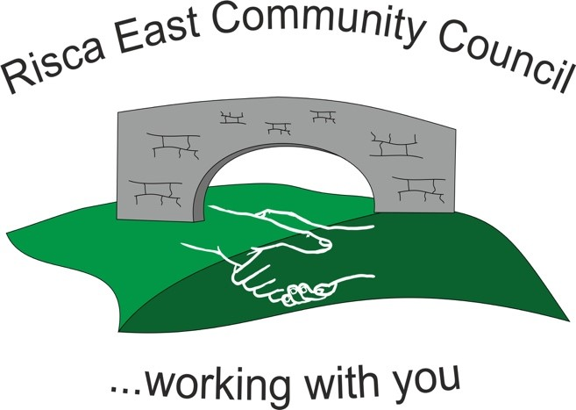

Clerk/RFO Nicola Roberts.
Village Farm, Manmoel, Blackwood
NP12 0RW
Tel. 07904 061754.
www.riscaeastcc.org.uk e-mail
riscaeastcommunitycouncil@outlook.com

Notice of conclusion audit
(Public Audit (Wales) Act 2004
Accounts and Audit (Wales) Regulations 2014)
Notice is hereby given that the audit for the year ended 31st March 2021 was completed on

7th May 2021

and the accounts are now available for inspection by local electors in accordance with Section 29 of the Public Audit (Wales) Act 2004.
The requisite information as defined by Section 11(4) of the Accounts and Audit (Wales) Regulations 2014 is not displayed alongside this notice.
If the requisite information is not displayed alongside this notice, it is available for inspection by appointment
To arrange a viewing please contact
Mrs Nicola Roberts, Clerk and R.F.O.,
Village Farm
Manmoel
Blackwood, NP12 0RW
Between the hours of 14:00 and 17:00
Monday to Friday

Dated 27th May 2022
This announcement was made by Nicola Roberts, Clerk and R.F.O. to Risca East Community Council.

Copies will be provided to any local government elector on payment of £5.00 for each copy of the Annual Return.

