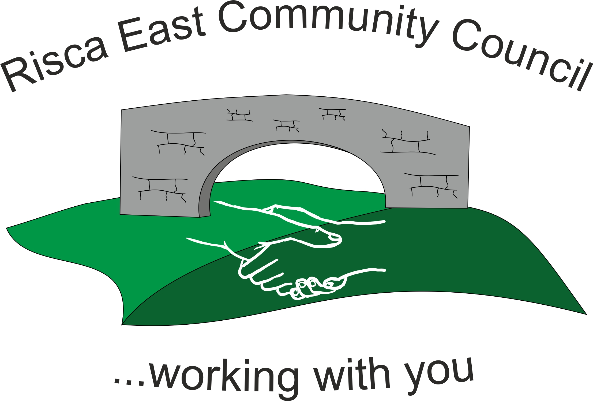 | Clerk/RFO Nicola Roberts  Village Farm  Manmoel  Blackwood  NP12 0RW  Tel. 07904 061754  www.riscaeastcc.org.uk  e-mail riscaeastcommunitycouncil@outlook.com
23-6-22 Meeting started 5 pm

6/22/1 Attendance and Apologies
To record attendance and receive apologies.
6/22/1.1 Community Councillors present – Councillors Nigel George, Christinne Thomas, Bernadette Martin

6/22/1.2 Apologies received from , Councillors Zoe Davies, Brandon Ham, Amy Billings, Philippa Leonard and Arrianna Leonard ..

6/22/2 Minutes of the previous meeting
These were received as a true record Cllr Chris Thomas proposed and Cllr Bernadette Martin seconded that the minutes were correct.

6/22/3 Matters arising from the minutes
- Web site maintenance and development –Cllr Brandon Ham explained that he has the necessary expertise to manage websites. It was agreed that he would help with bringing the website up to date. A new logo was discussed and agreed that the logo for the Jubilee leaflets would be used. This photo needs to be sent on to the Clerk
- Christmas lights – No movement on any catalogues for replacement lights.

- Risca Directory - It was established that the Directory did not reach all parts of the Community Council. It was agreed that Cllr Chris Thomas has contacted the Directory and ask for 200 copies that could be placed in shops to distribute to wider households.

- Queens Jubilee – Thanks were extended to Cllrs Zoe Davies and Chris Thomas for the organisation of the event.

- Defiblirator – this item will be referred to the next meeting.

6/22/4 To receive the financial report from the Clerk
6/22/4.1 The clerk ran through the report and the proposed expenditure was agreed. Approval was given for the cheques itemized, the bank balance was £23,152.10.
6/22/4.2 The accounts for 21/22 were approved.
6/22/4.3 The Internal Auditor’s report was considered and the recommendations noted.
6/22/4.4 It was agreed that a risk assessment would be prepared and considered by the committee.
6/22/4.5 It was also agreed that the clerk would provide a template for a contract of employment for consideration.
6/22/4.6 The annual return was agreed and approved by the Chairperson.

6/22/5 – Correspondance

6/22/5.1No applications received for the vacant Councillor post – this item will be referred to the next agenda.
6/22/5.2 An application has been submitted for the maintenance of the Risca Toilets – this will be discussed at the next committee meeting.

6/22/6 – Events
No new events are planned currently.

6/22/7 – To receive the report from Councillor Nigel George

6/22/7.1 There has been a bid placed under the levelling up fund for 3 porjects within the Borough. Approval is being sort for these bids.

6/22/8 To discuss local issues raised by Councillors

- Ty Sign Ward – Trees over hanging the footpath, Cllr Nigel George is to take this forward.

- Pontymister Upper Ward – there is a wall on Moraih Hill that has been knocked down, currently there is an issue of ownership of this piece of land.

- Trenewydd – there has been a number of problems with off roading vehicles on the public footpaths.

6/22/9 Planning Notifications
Two items noted and no objections raised.

6/22/10 Any other business
6/22/10.1 Cllr Chris Thomas requested the set up of a sub committee for the Risca Community Park. This was agreed, but as not all members were present the membership of the Committee will be decided at the next meeting.
6/22/10.4 – Date of next meeting 28th July 2022 at 6 pm for the Committee meeting to start at 6.30pm. Meeting closed at 6.20pm

Signed……………………………………………………….Chairman 28th July 2022

