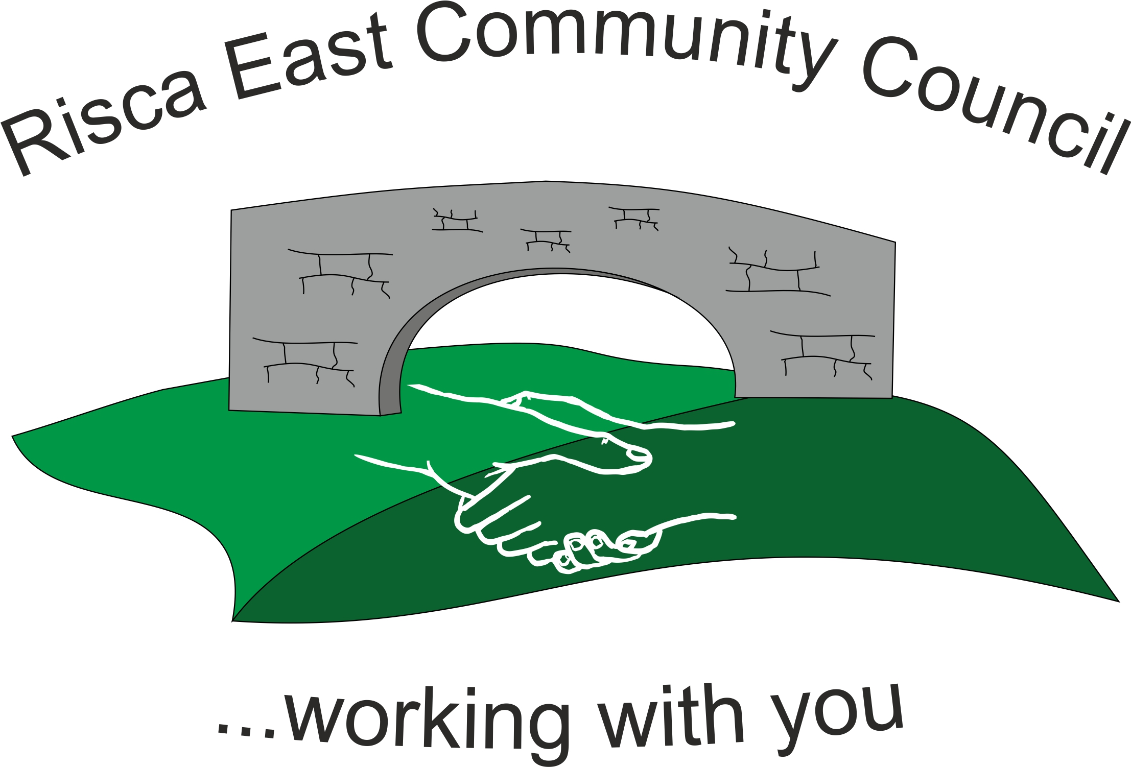 | Clerk/RFO Nicola Roberts  Village Farm  Manmoel  Blackwood  NP12 0RW  Tel. 07904 061754  www.riscaeastcc.org.uk  e-mail riscaeastcommunitycouncil@outlook.com
28-7-22 Meeting started 5:40 pm

7/22/1 Attendance and Apologies
To record attendance and receive apologies.
6/22/1.1 Community Councillors present – Councillors Nigel George, Christinne Thomas, Bernadette Martin, Zoe Davies, Arrianna Leonard, Phillippa Leonard guest Steve Vessey

6/22/1.2 Apologies received from , Councillors Amy Billings. Councillor Brandon Ham was hoping to join a bit later.

7/22/2 Minutes of the previous meeting
These were received as a true record Cllr Chris Thomas proposed and Cllr Bernadette Martin seconded that the minutes were correct.

7/22/3 Matters arising from the minutes
- Web site maintenance and development –This update was deferred until the september meeting.
- Defiblirator – this item was discussed and it was raised that there was a recall on a number of machines. The Clerk is to provide Cllr Zoe Davies with an access code so that the barcode can be checked.
- (1) Christmas tree – the current real has died and a discussed took place and it was decided to replace with another real tree as in the long run it would be more cost effective. Cllr Chris Thomas is to contact Raglan nurseries for a quote of a Norway spruce tree, the budget will be set once the quotes have been received. A new location was proposed on the corner of Ty-sign Community Park. Permission would need to be sought to have the tree planted here. The Clerk is to contact the Council to request permission.
Cllr Brandon Ham joined the meeting virtually.
(c ) (2) Christmas Lights - it was agreed that the two faulty lights would be replaced and a further 4 purchased in increase the compliment of Christmas lights. A vote was carried out on the most popular lights 2 x Father Christmas, 2 x Snowflakes and 2 x Reindeer lights were agreed.

7/22/4 To receive the financial report from the Clerk
7/22/4.1 The clerk ran through the report and the proposed expenditure was agreed. Approval was given for the cheques itemized, the bank balance was £22,613.46.
7/22/4.2 Forward approval was given for the cheque to be written for the August salary, renewal of the mircosoft licence and Society of Local Community Clerks membership.
7/22/4.3 The risk assessment would be prepared and considered by the next committee.

7/22/5 – Applications for vacancy on the Committee
No applications have been received. A discussion took place over the damaged notice board that needs repairing. Cllr Zoe Davies is to approach Howe Engineering for a quoate to repair and move the notice board to a new place.

7/22/6 Correspondance

7/22/6.1 – Steve Vessey ranthrough the application of funding £1,500 – the application was agreed in principle with a few amendments to be made to the application first.
Steve Vessey left the meeting.

7/22/6.2 – TLC Application for Grant funding £2,460 – Cllr Zoe Davies declared an interest and left the meeting. The Grant funding application was approved.
Cllr ZoeDavies returned to the meeting

7/22/6.3 An application was submitted for the maintenance of the Risca Toilets £3,500 – application was discussed and approved with one Councillor abstaining. Any future applications for this funding would be capped at £3,500.

7/22/7 – Events –
7/22/7.1 it was agreed to set up a sub Committee for the development of Ty Sign Community Park.
7/22/7.2 A date was set for the Remeberance Armatice Service on November 11th. Cllr Zoe Davies is to read the lessons.

7/22/8 – To receive the report from Councillor Phillippa Leonard

7/22/7.1 Elm drive parking is still under consideration.
7/22/7.2 Applications are being encouraged for the Empowerment fund.
7/22/7.3 Residents are being encouraged to take part in the adopt a lane scheme, we are also looking for volunteers to litter pick.

7/22/9 To discuss local issues raised by Councillors

- Ty Sign Ward – off roading bikes are becoming more of a problem, this needs to be reported to the police.

- Pontymister Upper Ward - more cases of anti social behaviour have been noted. CCBC has engaged more community councillors to help with this issue.

- Trenewydd – there has been a number of problems with off roading vehicles on the public footpaths.

7/22/10 Planning Notifications
No objections raised.

7/22/11 Any other business -

7/22/11.1 Foodbank funding was discussed and it was decided to invite them in to talk at the next meeting.
6/22/10.4 – Date of next meeting 14th September 2022 at 5.30 pm for the Committee meeting to. Meeting closed.

Signed……………………………………………………….Chairman th^{th} September 2022

