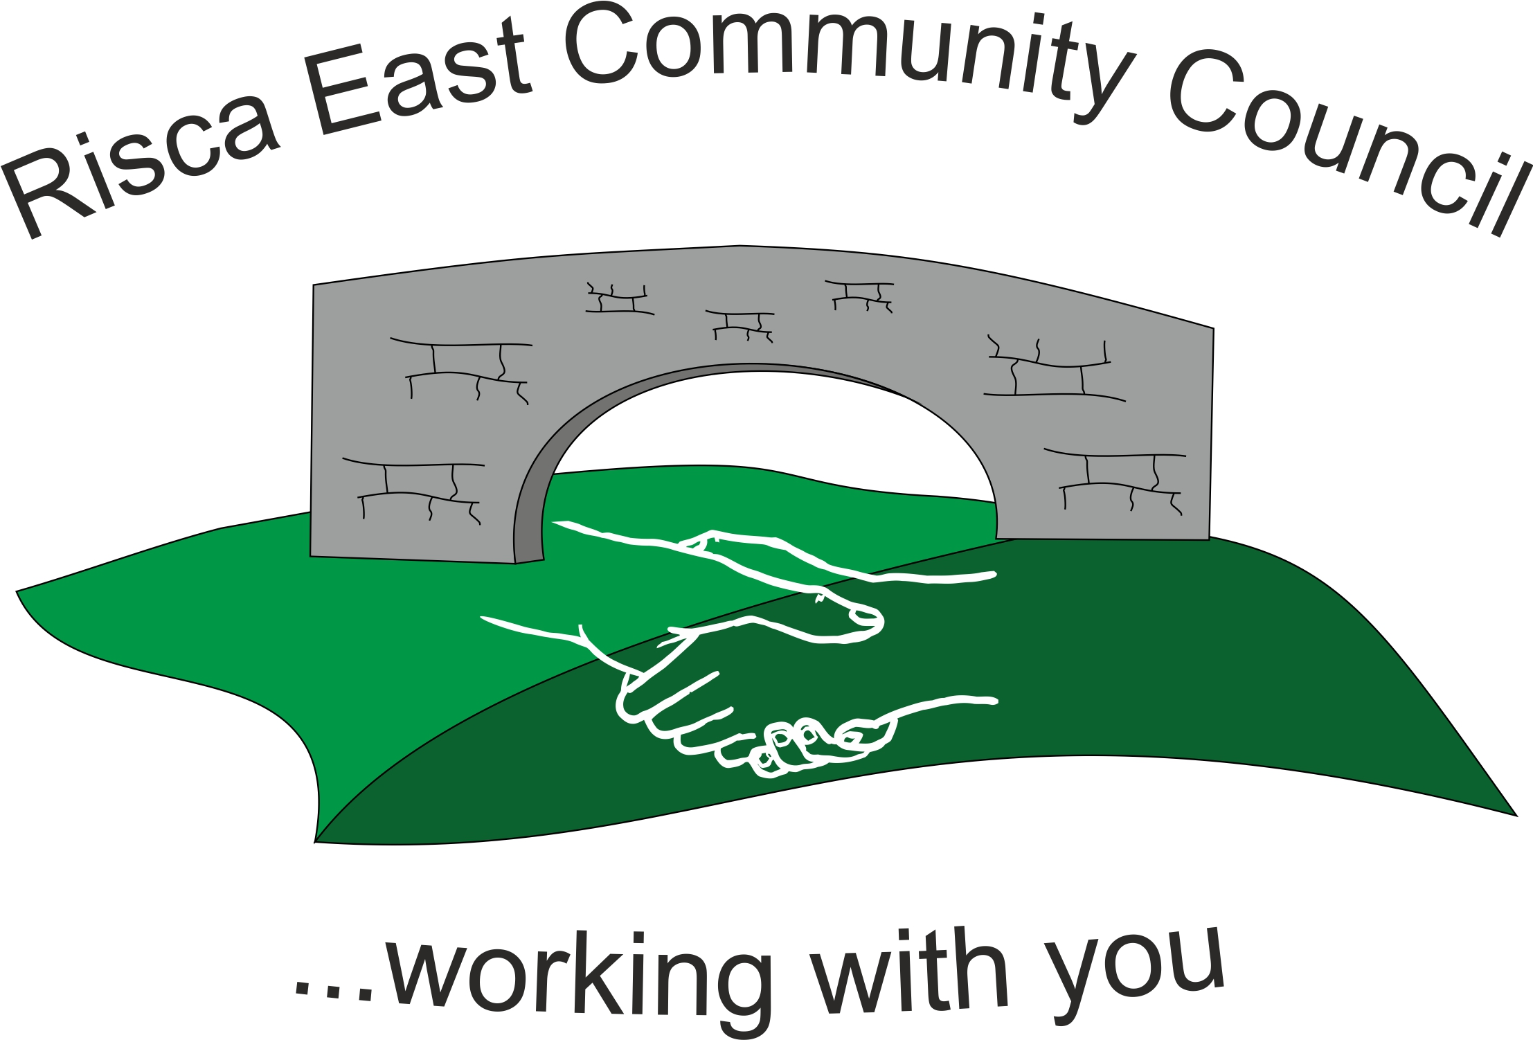 | Clerk/RFO Nicola Roberts  Village Farm  Manmoel  Blackwood  NP12 0RW  Tel. 07904 061754  www.riscaeastcc.org.uk  e-mail riscaeastcommunitycouncil@outlook.com
22-12-22 Meeting started 5:30 pm

12/22/1 Attendance and Apologies
To record attendance and receive apologies.
11/22/1.1 Community Councilors present – Councilors Christine Thomas, Zoe Davies, Brandon Ham, Roger Smith, Arianna Leonard, Philippa Leonard and Cllr Nigel George

12/22/1.2 Apologies received from , Councilors Bernadette Martin and Amy Billings. It was noted that Cllr Philippa Leonard had thought her apologies had been received for the Council meeting of 29/11/22 and apologised for the mix up.

12/22/2 Minutes of the previous meeting
These were received as a true record Cllr Chris Thomas proposed and Cllr Brandon Ham seconded that the minutes were correct.

12/22/3 Matters arising from the minutes
- Parking outside the local Primary – Cllr Brandon Ham gave an account of the meeting that was held with Mrs Sims the Head. Two options were discussed
  - Reinstatement of the Lollipop lady – an option would be to pay ½ of a salary in conjunction with the school for a 1 year basis. The cost would be in the region of £2,000 with on costs. This was voted on and 100% unanimous agreed.
  - Explore a car turning point at Wood view crescent. It was also agreed to let the Head Know that we would write to Housing and request that they explore the option of creating another access to the school to provide a drop off point only to alleviate the traffic from the main entrance.

- (1) Christmas tree and fete – The fete was successful and everyone was thanked for their contributions. It was noted that for next year a star would need to be purchased for the top of the tree. A map would also be obtained so that the location of the lights could be discussed. It was also noted that Elsbury mentioned that a fence around the tree should be considered.

- LDP and Youth Club – Cllr Philippa Leonard clarified some of the queries that had been raised and talked the Committee briefly through the LDP. Cllr Zoe Davies is to arrange a meeting for Paul O’Neil for the new year.

12/22/4 To receive the financial report from the Clerk
12/22/4.1 The clerk ran through the report and the proposed expenditure was agreed. Approval was given for the cheques itemised, the bank balance was £21,339.89.
12/22/4.2 The clerk will present a budget at the next meeting for ratification. The balance of funds was discussed, and it was decided that a list would be made of the committed expenditure to ensure enough funds would be available to pursue all of the events/ community activities and support that is planned. It was also agreed that a quote would be sought for fencing around part of the Ty Sign Community Park.

12/22/5 Correspondence

12/22/5.1 An email was shared with the Risca Town Council, it was agreed that the Clerk would go back and note the new venue of meeting for Risca East Community Council.

12/22/6 – Events –
12/22/7.1 The next major event is to the Kings Coronation

11/22/7 – To receive the report from Councilor Philippa Leonard
- An update on Elm Drive parking – work was to start on the 23/1/23, this was likely to be for a period of 10 weeks. There is likely to be disruption to parking in the short term whilst pavements are narrowed. There are plans for the Cllrs to visit residents to explain the works in advance of the start date. Street surgeries are also to be held to inform residents.
- The Channel View Xmas fair was not as busy as expected, this could be owing to a number of factors. Next year the date will be sooner.
- There was no update on the Bus service but two busses have been added and two extra stops have been added (Stow Hill and St Woolos).

12/22/8 To discuss local issues raised by Councilors

- Ty Sign Ward –
- Pontymister Upper Ward –

- Trenewydd –

All three areas were discussed in conjunction. Fly tipping was an issue, there was also a need for dropped Kerbs. Cllr Philippa Leonard will investigate.

12/22/9 Planning Notifications
22/0998/Full – Cllr Philippa Leonard was to present this to the Committee.

12/22/10 Any other business –

12/22/10.1 The dates of the committee meetings were discussed and the agreement was the first Friday of every month. This would be added to the website.

Date of next meeting 6th January 2023 at 5.30 pm.

Meeting closed 7pm

Signed……………………………………………………….Chairman 6th January 2022

