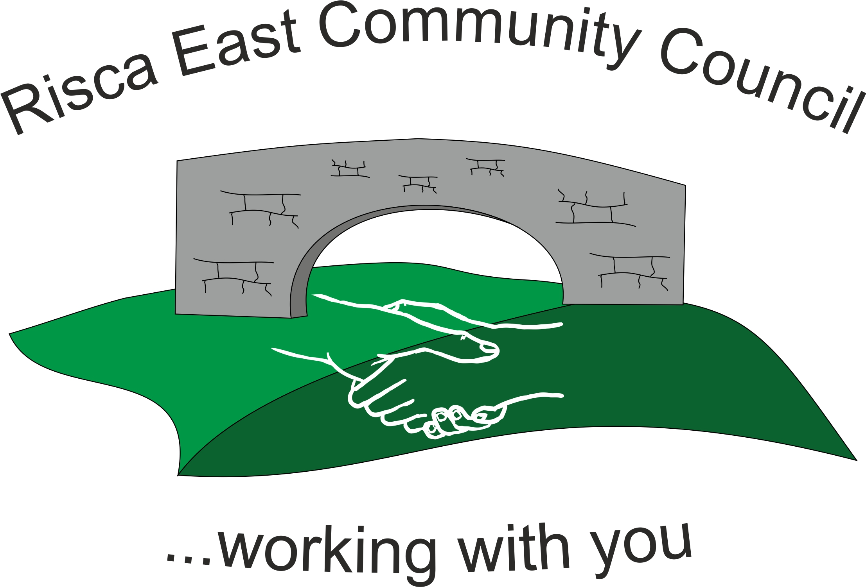 | Clerk/RFO Nicola Roberts  Village Farm  Manmoel  Blackwood  NP12 0RW  Tel. 07904 061754  www.riscaeastcc.org.uk  e-mail riscaeastcommunitycouncil@outlook.com
24-11-22 Meeting started 5:40 pm

11/22/1 Attendance and Apologies
To record attendance and receive apologies.
11/22/1.1 Community Councillors present – Councillors , Christinne Thomas, Bernadette Martin, Zoe Davies, Brandon Ham, guest Roger Smith

11/22/1.2 Apologies received from , Councillors Nigel George and Arrianna Leonard.

11/22/2 Minutes of the previous meeting
These were received as a true record Cllr Chris Thomas proposed and Cllr Bernadette Martin seconded that the minutes were correct.

11/22/3 Matters arising from the minutes
- Web site maintenance and development –The clerk is to resend email to Cllr Brandon Ham so that the website can incorporate the necessary changes.

- (1) Christmas tree – the tree has been planted and extra supports put in place.

(b)(2) Christmas Lights – The electric column has been installed and the Committee would like to test the lights prior to the switch on to ensure everything works. The Clerk is to obtain a map of the current street lights with locations etc so that any new lights that are purchased can be appropriately located.

11/22/4 To receive the financial report from the Clerk
11/22/4.1 The clerk ran through the report and the proposed expenditure was agreed. Approval was given for the cheques itemised, the bank balance was £22,489.07.
11/22/4.2 The clerk asked about the details of the precept and it was decided to prepare a budget based on a nil increase for discussion at the next committee meeting.

11/22/5 – Applications for vacancy on the Committee
Roger Smith expressed his interest in applying for the vacant post. He introduced himself and the Committee voted to accept his verbal application.

11/22/6 Correspondence

11/22/6.1 – An email was received off a local resident regarding the planned alteration to the bus service times and routes. It was discussed and decided that the Clerk was to ask Cllr Philippa Leonard the details of the bus company that was contacted previously.

11/22/6.2 The meeting for the parking will be attended on Monday 28/11/22 and feedback will be brought to the next meeting.
11/22/6.3 The clerks contract of employment was agreed and signed.
11/22/6.4 The new salary scales were brought to the committee’s attention

11/22/7 – Events –
11/22/7.1 The Christmas was discussed and posters agreed

11/22/8 – To receive the report from Councilor Philippa Leonard
No County councilors were present.

11/22/9 To discuss local issues raised by Councilors

- Ty Sign Ward –
- Pontymister Upper Ward –

- Trenewydd –

All three areas were discussed in conjunction. The County Council has issued the second stage of the LDP. The Councilor’s expressed their views and some of the views of the constituents. Brandon Ham will forward an email onto the clerk to distribute to the members so that any opinions can be expressed via the planning portal.

11/22/10 Planning Notifications
No objections raised.

11/22/11 Any other business –

11/22/11.1 The Natural Resource Wales and the Woodland trust were offering a tree per household, to plant in a garden etc.

11/22/11.2 The local school were also interested in preparing a time capsule. This will be led by Cllr Zoe Davies and prepared to coincide with the coronation of the King Charles.

Date of next meeting 22nd December 2022 at 5.30 pm.

Meeting closed 7:11pm

Signed……………………………………………………….Chairman th^{th} November 2022

