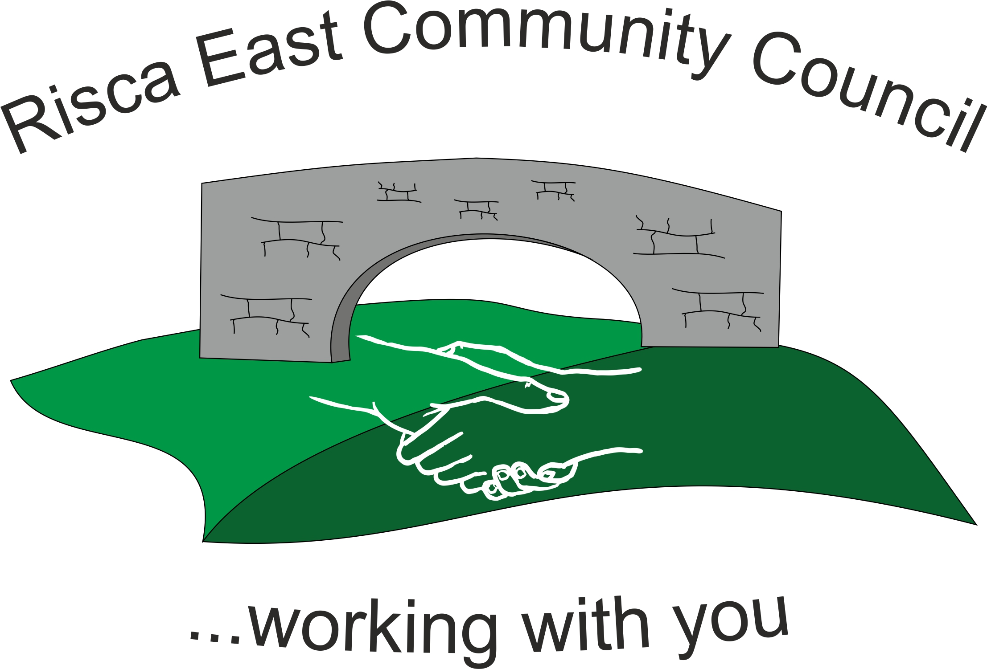 | Clerk/RFO Nicola Roberts  Village Farm  Manmoel  Blackwood  NP12 0RW  Tel. 07904 061754  www.riscaeastcc.org.uk  e-mail riscaeastcommunitycouncil@outlook.com
3-3-23 Meeting started 5:30 pm

3/23/1 Attendance and Apologies
To record attendance and receive apologies.
3/23/1.1 Community Councilors present – Councilors Christine Thomas, Zoe Davies, Roger Smith, Arianna Leonard, Philippa Leonard, Bernadette Martin and Cllr Nigel George, Amy Billings

3/23/1.2 Apologies received from Councilor Brandon Ham and Clerk.

3/23/2 Minutes of the previous meeting
These were received as a true record and signed.

3/23/3 Matters arising from the minutes
- Parking outside the local Primary –
  - 1 & 2 Parking at the primary school- Meeting held with all 3 borough councillors and chair ZD with Lynn John and Sara Bowen. Land on Thistle way was confirmed as being held under the title of HOUSING by CCBC. A number of different options were discussed however taking into consideration the wildlife on the local Canal and the number of consultations that would be needed. It was concluded that different solutions would be needed.

- LDP and Youth Club – This point to be carried forward to the next meeting after the joint meeting with Risca Town Council.
- PL was to contact Tracy Lundy to get permission needed for a sign to be erected for Ty-Sign Community Park

3/23/4 To receive the financial report from the Clerk
3/23/4.1 Paperwork was read through and approved.

3/23/5 Correspondence – none

3/23/6 – Events –
(1) AL PL AB BH main objective all advertainment and stalls for the event
(2) ZD NG BM RS (CT) main objective full installation of all park features and liaison with schools in regard to competitions ( cutting ribbon)

3/23/6.1 Date of tree delivery and installation of benches was discussed
Group agreed to set up 2 sub-groups to complete all tasks for this event
3/23/6.3 (1) AL PL AB BH main objective all advertainment and stalls for the event
(2) ZD NG BM RS (CT) main objective full installation of all park features and liaison with schools in regard to competitions ( cutting ribbon)

3/23/7 – To receive the report from Councilor Nigel George
- An update on Elm Drive parking

3/23/8 To discuss local issues raised by Councilors

- Ty Sign Ward –
- Pontymister Upper Ward –

- Trenewydd –

All three areas were discussed in conjunction and it was the use of unlicensed motorbikes.

3/23/9 Planning Notifications
Nothing to note.

3/23/10 Any other business –

AB questioning as to if she is still the councils OVW rep as BH has just received training from them. She was also made aware by the Chair of her recent absences.

All agreed on a fence to be fitted around the Christmas tree

Receipts received from BM for small items in regard to coronation

Date of next meeting to be moved to be circulated in email

New point to be added to constitution by unanimous vote that sub-groups can spend £500-£1000max without the agreement of the full group

Councillor Chris Thomas co-opted back on (notice handed in during month between meetings) by a unanimous vote

Date of next meeting 31st March 2023 at 5.30 pm.

Meeting closed

Signed……………/………………………………………….Chairman 31st March 2023

