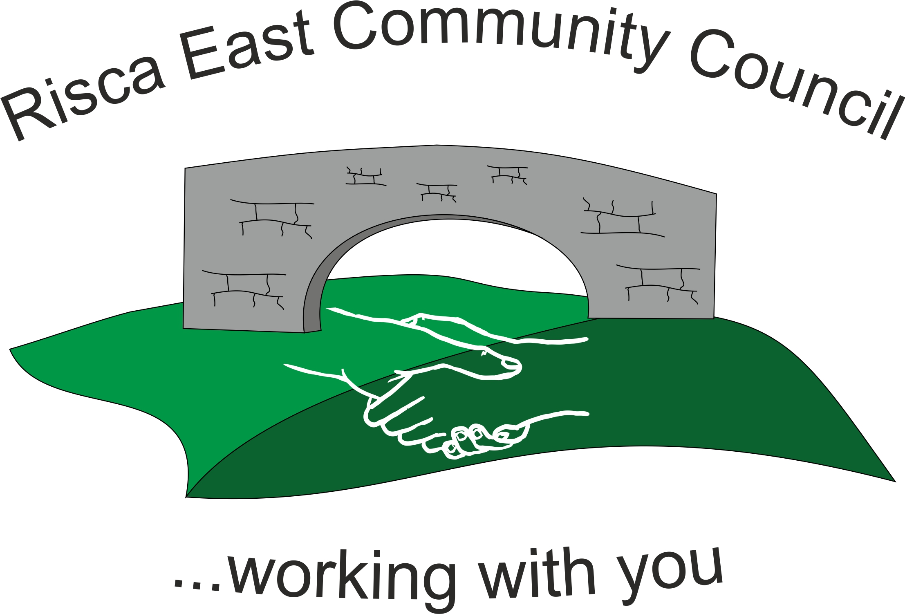 | Clerk/RFO Nicola Roberts  Village Farm  Manmoel  Blackwood  NP12 0RW  Tel. 07904 061754  www.riscaeastcc.org.uk  e-mail riscaeastcommunitycouncil@outlook.com
Minutes of the Annual General Meeting of Risca East Community Council held on Tuesday 5th May 2023 at 5.30 pm in the TLC in Tysign Risca.

5-5-23 Meeting started 17.30
pm

AGM 23/1 Attendance and Apologies
To record attendance and receive apologies.
AGM 23/1.1 Community Councillors present – Councillors Zoe Davies, Nigel George, Christinne Thomas, Philippa Leonard, Bernadette Martin, Arrianna Leonard, Amy Billings and Brandon Ham, Roger Smith

AGM 23/2 To Elect a Chairperson for the forth coming year
Cllr Nigel George was proposed votes were unanimous.

AGM 23/3 To elect a Vice Chair for the forth coming year
Councillor Zoe Davies was voted as Chair person for the forth coming year votes were unanimous.
AGM 23/4 To sign declaration of office by newly elected Chair Person
The acceptance is to be signed upon receipt of the paperwork.

AGM 23/5 Minutes of the previous meeting
Agreed as correct.

AGM 23/5.1 Advertising for the Council Vacancy
No vacancies

AGM 23/6 To elect representatives on the following Committees:
AGM 23/6.1 Caerphilly County Borough Council Town and Community Councils Joint Liaison Committee – Cllrs Nigel George, Zoe Davies, Arrianna Leonard and Bernadette Martin were elected.
AGM 23/6.2 Ty Sign Primary School – Cllr Zoe Davies and Cllr Brandon Ham were elected last year and there term is for 4 years.
AGM 23/6.3 Risca Town Centre Management Committee – Cllrs Bernadette Martin and Chris Thomas together with the 3 County Borough Councillors.
AGM 23/6.4 One Voice Wales - Cllr Amy Billings and Cllr Brandon Ham.

1056 To decide upon the Chair person’s Allowance for 2022/23 in pursuance of the Local Government Act 1972
As Cllr Nigel George is a County Councillor now allowance will be taken for 23/24.

Meeting closed at 17:40 pm.

Signed……………………………………………………….Chairman May 2024

