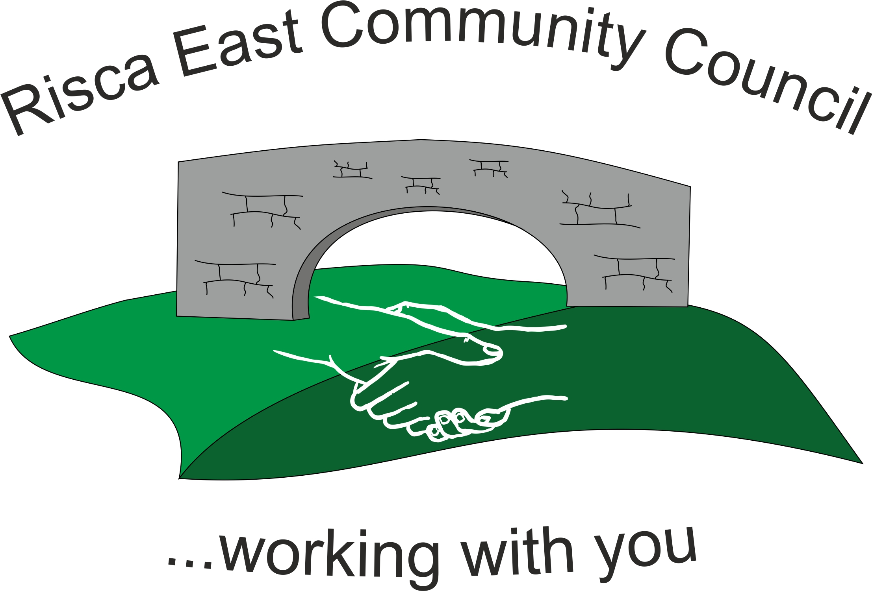 | Clerk/RFO Nicola Roberts  Village Farm  Manmoel  Blackwood  NP12 0RW  Tel. 07904 061754  www.riscaeastcc.org.uk  e-mail riscaeastcommunitycouncil@outlook.com
7-7-23 Meeting started 5:30 pm

7/23/1 Attendance and Apologies
To record attendance and receive apologies.
7/23/1.1 Community Councilors present – Councilors , Bernadette Martin, Zoe Davies, Brandon Ham, Nigel George, Philippa and Arianna Leonard, Roger Smithand Cllr Chris Thomas. Chair was Cllr Nigel George..

7/23/1.2 It was noted that Cllr Amy Billings formally handed her notice as Councillor. The Committee wanted to thank her for her contributions and asked the Clerk to send a letter.

7/23/2 Minutes of the previous meeting
These were received as a true record Cllr Zoe Davies proposed and Cllr Brandon Ham seconded that the minutes were correct. It was noted that Apologies had been accepted from Chris Thomas and that had been omitted but hand written on.

7/23/3 Matters arising from the minutes
- Christmas Lights – The Clerk is to ensure an agreement exists with CCBC for the use of electric for the electric column installed on the Ty Sign park. Clerk is now to contact parks to pursue this.
- Xmas lights to be taken to next meeting.

7/23/4 To receive the financial report from the Clerk
7/23/4.1 The clerk ran through the report and the proposed expenditure was agreed. Approval was given for the cheques itemised, the bank balance was £16,505.12. The invoices were received after the committee papers were sent out. A number of cheques were also written after the papers were issued and these were discussed verbally and will be included on the next meeting.

The allowance for the Chair for 22-23 was used to purchase a laptop, the balance of £80.01 was then paid to the chair.

Reimbursement for costs for the outdoor cinema was made to Chris Thomas for £200 and £8.39. Reimbursement was also made to A Leonard for £49.19 for costs for the outdoor cinema.

The Clerk mentioned that when the purchase cost was made for the Clerk’s laptop there was an option to purchase extra warranty – this was declined.
The committed costs were examined and a few alterations were made going forward.
A number of actions came out of this:
- PL to determine what the situation is with Adrian Browning from the foodbank
- Hafodybryn benches – NG to enquire if maybe a bench needs to be moved as a result of antisocial behaviour and this could be relocated to hafodbryn – this would reduce costs.

7/23/5 Correspondence

The Clerk raised the issue of not being able to recruit an internal auditor The return was signed and approved by the committee. The planned internal auditor was arranged but didn’t go ahead at the last minute due to illness. Another internal auditor was to be arranged.

A letter updating the position on the application of funding from Pontywaun County School Memorial Garden. It was decided to ask for the return of the funding and another application could be submitted for further consideration.

.

7/23/6 – Events –

7/23/6.1. Cinema – to date £650 was raised in donations from small businesses wanting to advertise in the program designed by the events committee.

7/23/6.2 The clerk updated on position with electric column and informed the committee that she had been referred to parks. NG stated that he had a meeting scheduled with Mike Headington and would raise the issue.

7/23/6.3 Next events to consider would be Armistice and Christmas fayre. On the point of Christmas it was pointed out that the tree had been vandalised so that it was unlikely to grow anymore. Therefore Chris Thomas was approved to research some quotes for new trees or artificial ones.

7/23/7 – To receive the report from Community Councillors
7/23/7.1 It was noted that Stagecoach were terminating the Monday to Saturday R1 service – last 3 buses 8pm – 10pm.

7/23/7.2 The terrapins in the canal are going to be relocated in order to maintain the eco balance.

7/23/8 To discuss local issues raised by Councilors

- Ty Sign Ward – may be some mix up over the location of flats. Some residents had complained about refuse removal and others had received letters from CCBC. The parking in Elm Drive was a slow process but still ongoing.

- Pontymister Upper Ward – there was a fire in the hedge in Ty Sign – luckily this was contained

- Trenewydd – It was also noted that the ally way corner of Quantock and Cheviot was extremely overgrown. ZD and BM to gather more information so that it can be reported. Still ongoing,

7/23/9 Planning Notifications
Applications were noted and no objections raised.

7/23/10 Any other business –

Date of next meeting 7th September 2023 at 5.30 pm.

Meeting closed 18:40 pm
Signed……………………………………………………….Chairman7 ^{th} September 2023

