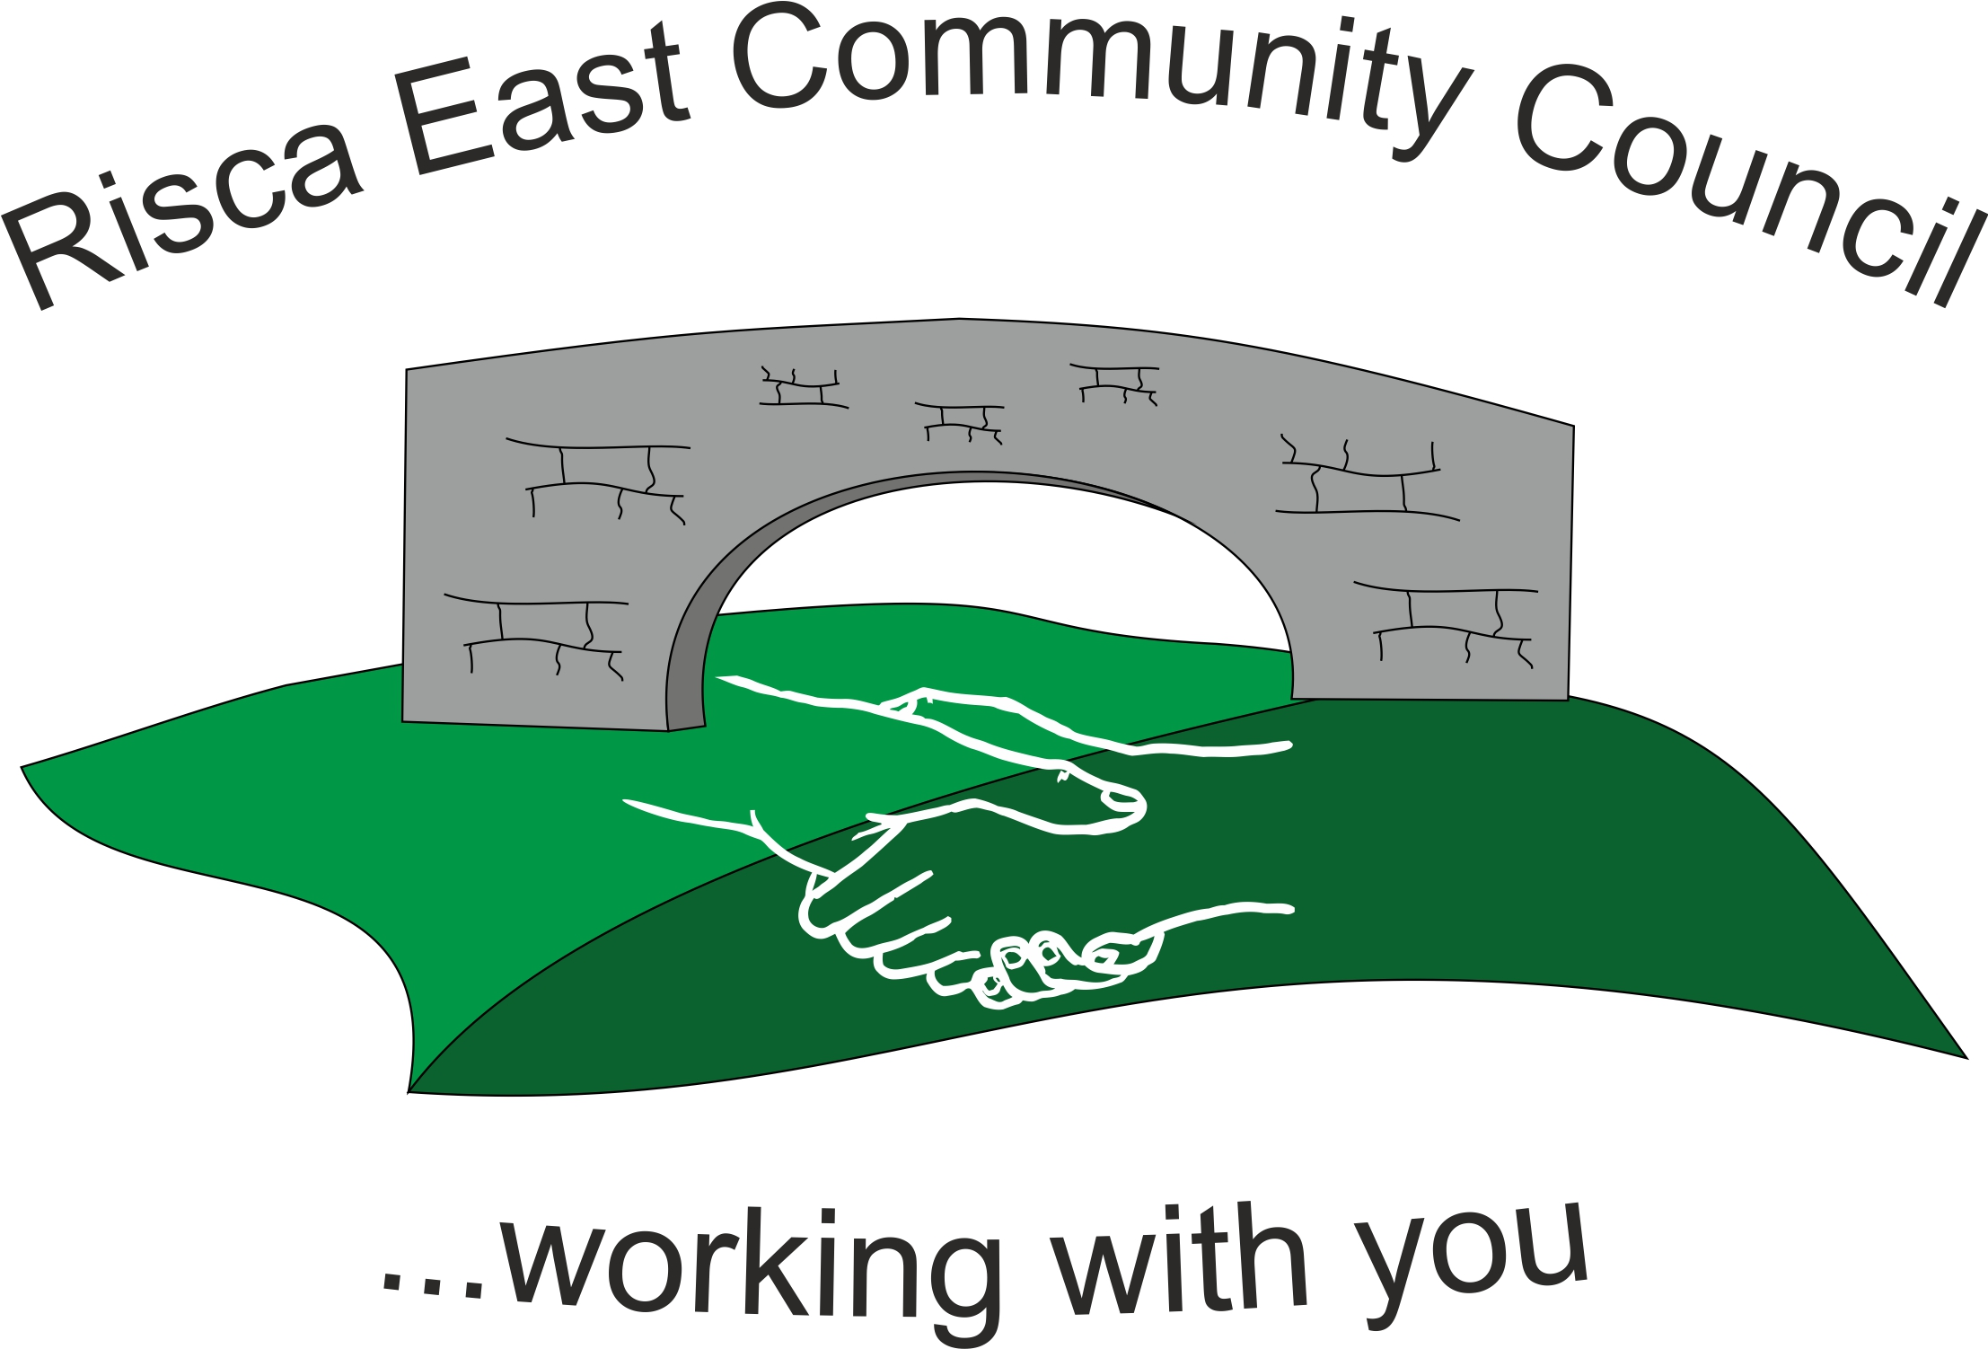 | Clerk/RFO Nicola Roberts  Village Farm  Manmoel  Blackwood  NP12 0RW  Tel. 07904 061754  www.riscaeastcc.org.uk  e-mail riscaeastcommunitycouncil@outlook.com
6-10-23 Meeting started 17:43pm

10/23/1 Attendance and Apologies
To record attendance and receive apologies.
10/23/1.1 Community Councillors present – Councillors Nigel George, Christinne Thomas, Bernadette Martin, Philippa Leonard and Arrianna Leonard, Roger Smith .
10/23/1.2 Apologies received from Cllr Zoe Davies and Cllr Brandon Ham.

10/23/2 Minutes of the previous meeting
These were received as a true record Cllr Phillippa Leonard proposed and Cllr Cernadette seconded that the minutes were correct.

10/23/3 Matters arising from the minutes
- Wreaths – this have been ordered by Cllr Chris Thomas.
- Notice Board – this had the go ahead to progress.

10/23/4 To receive the financial report from the Clerk
a) The clerk ran through the report and the proposed expenditure was agreed. Approval was given for the cheques itemized, the bank balance was £11,324.27.

b) The Clerk explained that although Amy Billings had verbally stated that she did not wish to receive the Councillor allowance, a written confirmation of this is needed.

c)The clerk went through the list of commitments in order to update the committed costs going forward. These will be incorporated into the figures for next months meeting.

10/23/5 – Correspondance

10/23/5.1 Email from Risca Town Council in relation to the estimated cost for the new flag pole in Darren Gardens. This is estimated at £599 and noted by the Committee.
10/23/5.2 A funding application was received from Croppers Hair dressers for help with the purchase of new shutters for the shop front. After consideration they application was denied – unanimous decision.
10/23/5.3 Vacant set to remain until any applications are received.

10/23/6 – Events
10/23/6.1 – a list of courses from One Voice Wales are to be brought to each meeting in advance of anyone attending. This would everyone the benefit of determining which courses would be of the best benefit.
10/23/6.2 – Cllr Roger Smith has received a positive letter from the Monmouthshire Building Society stating they would be happy to donate in our events.
10/23/6.3 Cost of the selection boxes have increased a budget was given for £400. The other projected costs would be supplied after the events sub committee have met and be brought to the next meeting.
10/23/6.4 – Father Christmas outfit to be purchased – Cllr B Martin to consider the options.

10/23/7 – To receive the report from the County Borough Councillors

10/23/7.1 The County Borough Council have launched the LEAD programme with regards to responsible dog ownership.
10/23/7.2 Anti social behavior – The Community Wardens have increased their presence in the area.

10/23/8 To discuss local issues raised by Councillors

- Ty Sign Ward – nothing to report

- Pontymister Upper Ward – nothing to report.

- Trenewydd – the parking on Manor way has been reported to CCBC.

10/23/9 Planning Notifications
None

10/23/10 Any other business
None

Date of next meeting 3rd November 2023 at 5.30 pm for the Committee meeting to start at 6.30pm Meeting closed at 6:47pm

Signed……………………………………………………….Chairman 23rd June 2022

