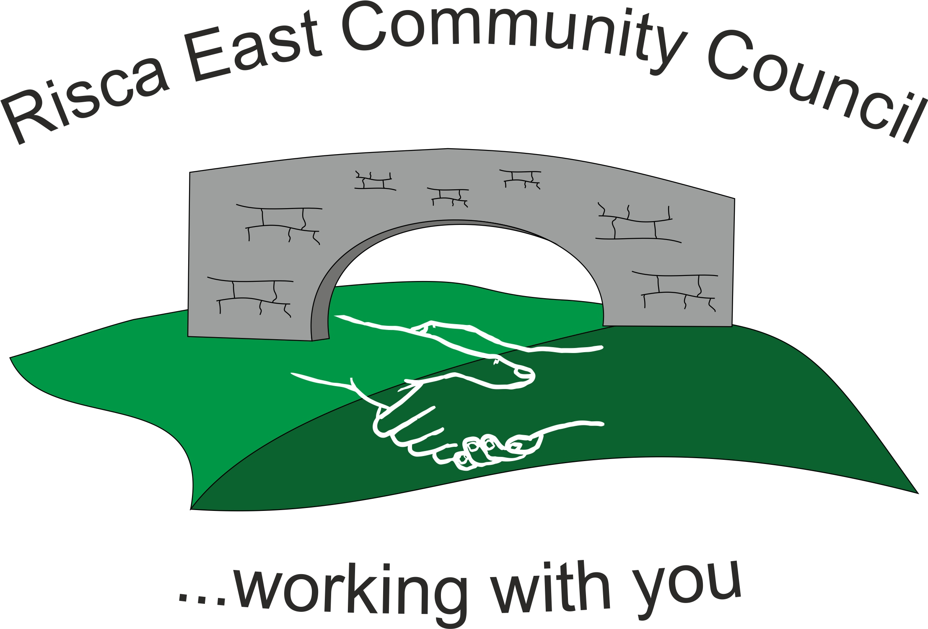 | Clerk/RFO Nicola Roberts  Village Farm  Manmoel  Blackwood  NP12 0RW  Tel. 07904 061754  www.riscaeastcc.org.uk  e-mail riscaeastcommunitycouncil@outlook.com
8-3-24 Meeting started 17:36pm

3/24/1 Attendance and Apologies
To record attendance and receive apologies.
3/24/1.1 Community Councillors present – Councillors Nigel George, Christinne Thomas, Bernadette Martin, Philippa Leonard, Roger Smith, Brandon Ham and Cllr Arianna Leonard.

3/24B/1.2 Apologies received from Cllr Zoe Davies.

3/24/2 Minutes of the previous meeting
These were received as a true record Cllr Arrianna Leonard proposed and Cllr Bernadette Martin seconded that the minutes were correct.

3/24/3 Matters arising from the minutes
- Lights – The committee was expecting feedback from the Lighting contractor who introduced themselves at the last meeting. Clerk to contact him and request that he attend and feedback at the next meeting.

3/24/4 To receive the financial report from the Clerk
a) The clerk ran through the report and the proposed expenditure was agreed. Approval was given for the cheques itemised, the bank balance was £18,615.16.

b) Worked through the committed expenditure.

3/24/6 – Correspondance

3/24/5.1 The Clerk brought up that after the meeting last month it was noted that the amount agreed to be paid as a grant to the vetrens group was incorrect for the rental of the TLC. This new amount was agreed and it was also clarified that the TLC would be invoicing the Council. Therefore payment would be paid direct to the TLC.

3/24/5.2 An email was received by Cllr Arrianna Leonard from Instadia Solutions. They has enquired about the events for the summer. They had been requested to forward a number of quotes for different options for the summer events and this could be considered by the Committee.

3/24/5.3 Vacant set to remain until any applications are received.

3/24/6 – Events
3/24/6.1 – Cllr Philippa Leonard asked to attend the events committee. The venue for the Sub Committee was agreed and some dates would be sent around the next few days for agreement to meet.
3/24/6.2 – The summer fayre will be considered at the next meeting of the committee. It was discussed as an option to install a number of poles so that under cover events could be considered and therefore would not be too weather reliant.

3/24/7 – To receive the report from the County Borough Councillors

3/24/7.1 Anti social behaviour was still a problem. A meeting was going to be set up between the Community Wardens, Police and residents. This would cover the processes in place to report such instances. This would take place in Risca Library so that any concerns could be raised.

3/24/8 To discuss local issues raised by Councillors

- Still waiting for progress on the Double yellow lines scheduled to commence.
- Pot holes – these have been marked up but have still yet to be started.
- Car Park – there is plan for a new car park in Pontymister by the vets. It is planned to have a gravel base.
- A complaint had been received about over hanging trees on the canal
- The referrals for the foodbank are unfortunately increasing. The foodbank was also asking for donations.

3/24/9 Planning Notifications
No planning applications for the period..

3/24/10 Any other business
3/24/10.1 Cllr Chris Thomas – had received a quote from Signet Signs to deliver 2,500 A4 folded leaflets six monthly for £220. Another Dor-2-Dor firm was also approached who quoted £200 for 2,400 leaflets. The quotes were approved. It was agreed that every Councilor would complete 200 words for the next edition. Matter to be discussed at the next meeting.

3/24/10.2 The Council’s website is also to be considered on the next agenda. The clerk is to have training on Website management. One Voice Wales to be contacted for recommendation.

3/24/10.3 As there is money available in the community empowerment fund, a “kick bar” could be considered to be placed on the border of Tysign park. Potential costs to be considered. This was discussed at length. Should there be any shortfall in the funding then Risca East could consider the request.

3/24/10.4 The quote for the removal of the old notice board and replace with a new one ios £560. This was unanimously approved. The ground needs to be dry before the work can commence.

3/24/10.5 Cllr Chris Thomas clarified that the Committee were still happy for her to continue with representing the Committee on the RBL Committee. All agreed.

Date of next meeting 5th April 2024 at 5.30 pm for the Committee meeting to start at 5.30pm at Channel View Community Centre.

Meeting closed at 18:36pm

Signed……………………………………………………….Chairman 5th^{rd} April 2024

