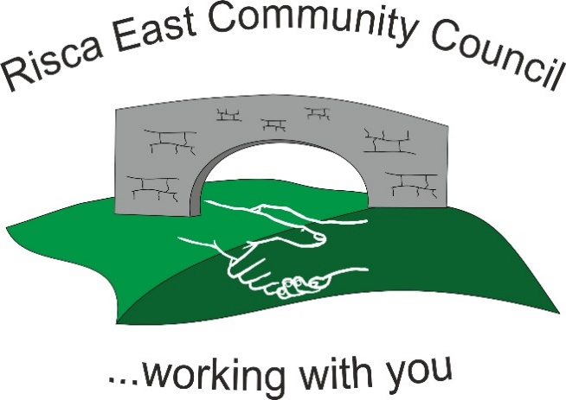 | Clerk/RFO Nicola Roberts.  Village Farm,  Manmoel, Blackwood, Caerphilly.  NP12 0RW.  Tel. 07904 061754.  www.riscaeastcc.org.uk  e-mailriscaeastcommunitycouncil@outlook.com

10th | May 2024
14th | June 2024
12th | July 2024
13th | September 2024
11th | October 2024
15th | November 2024
13 th | December 2024
24th | November 2022

