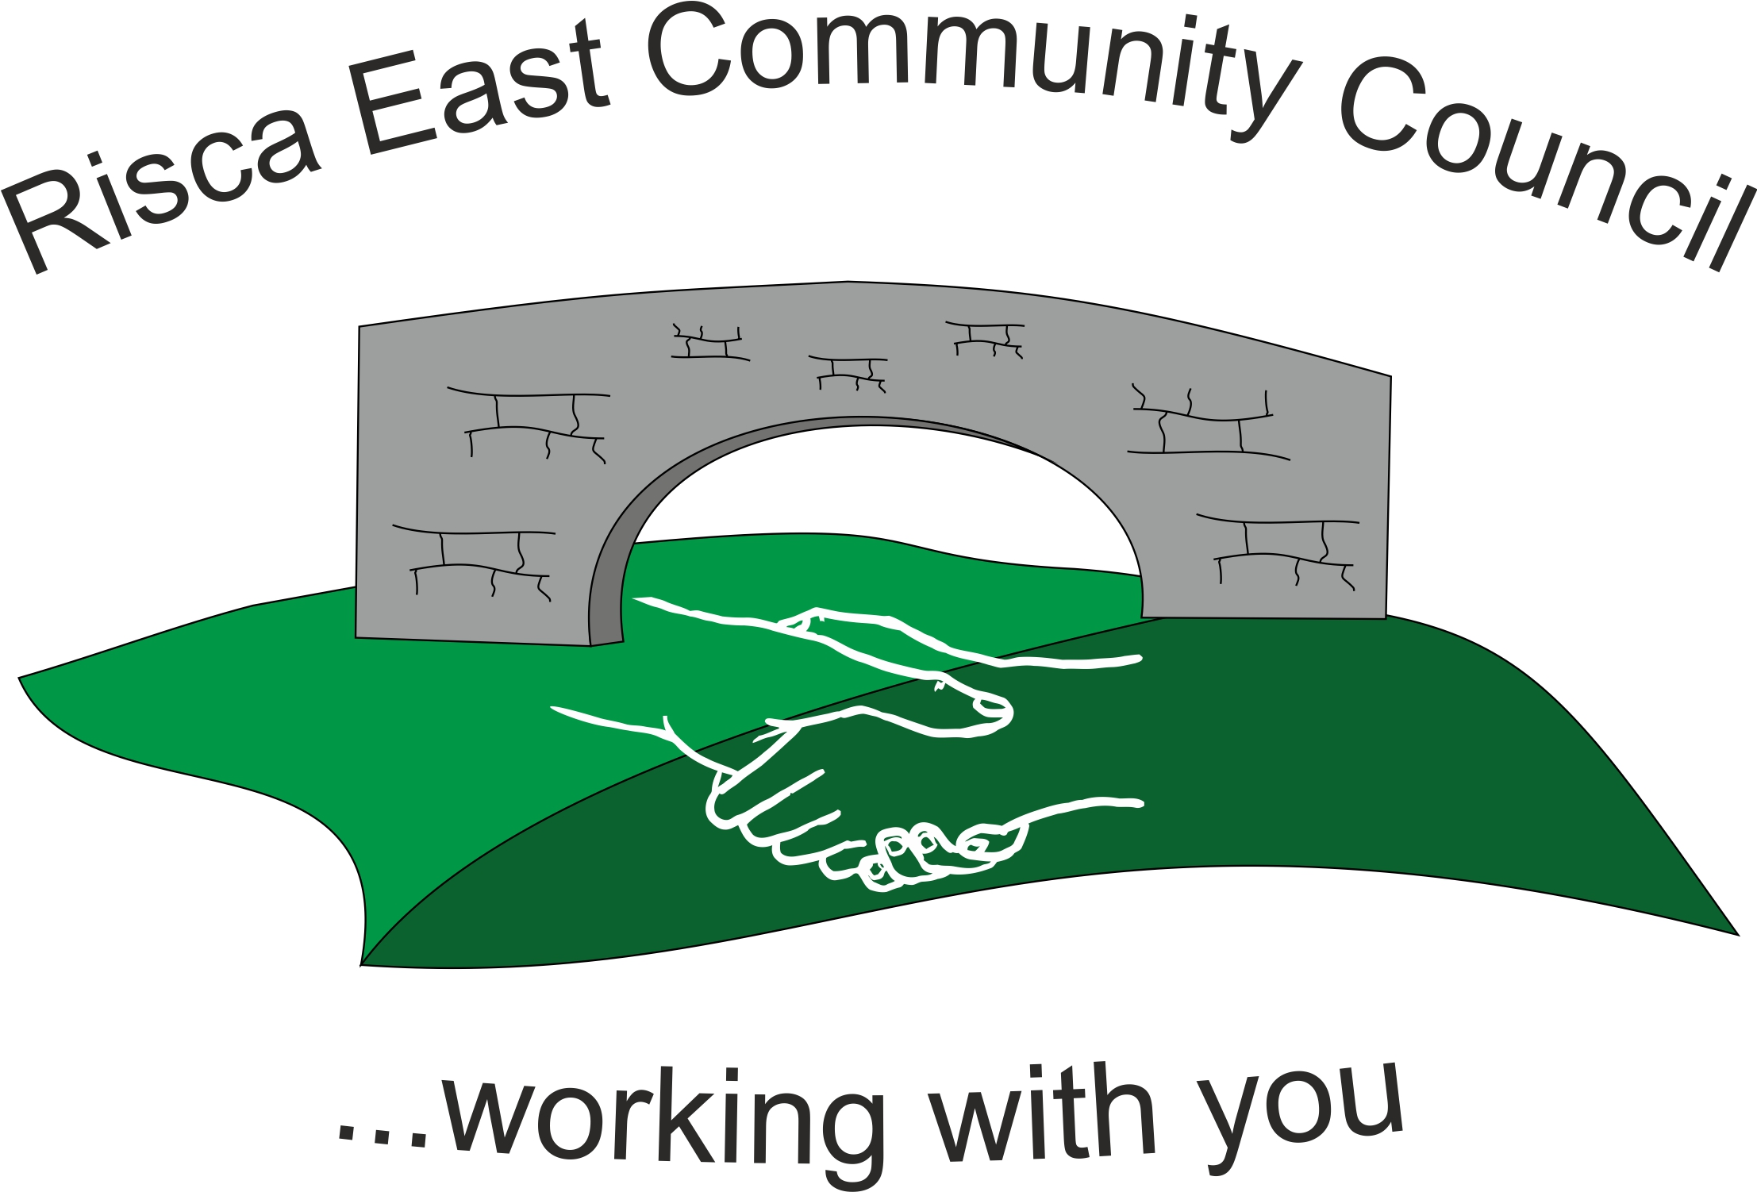 | Clerk/RFO Nicola Roberts  Village Farm  Manmoel  Blackwood  Caerphilly  NP12 0RW  Tel. 07904 061754  www.riscaeastcc.org.uk  e-mail riscaeastcommunitycouncil@outlook.com
9th May 2025
Dear Councillor,
The Annual General Meeting of Risca East Community Council will take place on Friday 9th May at 5.30 p.m. in the Channel View
Agenda.
AGM 25/1 To sign the register and to receive apologies.
AGM 25/2 To elect a Chairman for year 205/26.
AGM 25/3 To elect a Vice-Chairman for year 2025/26.
AGM 25/4 To sign a declaration of acceptance of office by the newly elected Chairman.
AGM 25/5 To approve the minutes of the Annual General Meeting held on 23rd May 2024
25/5.1 Matters arising
25/5.2 To decide on advertising for Council Vacancy
AGM 24/6 To elect representatives to serve on the following committees.
25/6.1 Caerphilly County Borough Council Town and Community Councils Joint Liaison Committee. (One representative, Clerk ex officio).
25/6.2 Ty Sign Primary School Governing Body. (One representative).
25/6.3 Risca Town Centre Management Committee, (Two representatives).
25/6.4 One Voice Wales
25/6.5 Any other committees nominated and agreed at the AGM.
AGM 25/7 To decide upon the amount of Chairman’s Allowance for 2025/26 in pursuance of the Local Government Act 1972.

