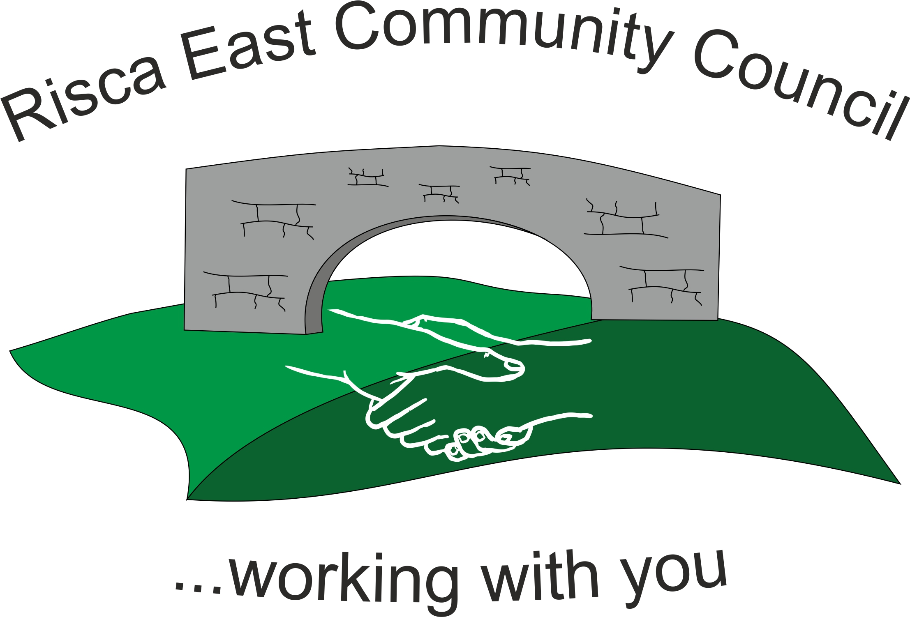 | Clerk/RFO Nicola Roberts  Village Farm  Manmoel  Blackwood  NP12 0RW  Tel. 07904 061754  www.riscaeastcc.org.uk  e-mail riscaeastcommunitycouncil@outlook.com
Minutes of the Annual General Meeting of Risca East Community Council held on Tuesday 10^{h} May 2024 at 5.30 pm in the Channel View Community Centre Risca.

10-5-24 Meeting started 17.40pm

AGM 24/1 Attendance and Apologies
To record attendance and receive apologies.
AGM 24/1.1 Community Councillors present – Councillors Zoe Davies, Nigel George, Christinne Thomas, Philippa Leonard, Bernadette Martin, Arrianna Leonard and, Roger Smith

Apologies: Brandom Ham who also passed on his preferences for reporesentation for the coming year.

AGM 24/2 To Elect a Chairperson for the forth coming year
Cllr Nigel George was proposed votes were unanimous.

AGM 24/3 To elect a Vice Chair for the forth coming year
Councillor Zoe Davies was proposed as Vice Chair person for the forth coming year votes were unanimous.

AGM 24/4 To sign declaration of office by newly elected Chair Person
The acceptance is to be signed upon receipt of the paperwork.

AGM 24/5 Minutes of the previous meeting
Agreed as correct.

AGM 24/5.1 Advertising for the Council Vacancy
Viram Goraniya submitted an application with a brief resume – this was approved unanimously. No others were received.

AGM 24/6 To elect representatives on the following Committees:
AGM 24/6.1 Caerphilly County Borough Council Town and Community Councils Joint Liaison Committee – Cllrs Nigel George, Zoe Davies, Arrianna Leonard as County Borough Councillors and Bernadette Martin was elected.
AGM 24/6.2 Ty Sign Primary School – Cllr Zoe Davies and Cllr Brandon Ham were elected last year and there term is for 4 years.
AGM 24/6.3 Risca Town Centre Management Committee – Cllrs Bernadette Martin and Chris Thomas together with the 3 County Borough Councillors. Clerk was to clarify that this Committee was still in existence.
AGM 24/6.4 One Voice Wales - Cllr Zoe Davies and Cllr Brandon Ham.

AGM 24/6.5 To decide upon the Chair person’s Allowance for 2022/23 in pursuance of the Local Government Act 1972
As Cllr Nigel George is a County Councillor no allowance will be taken for 24/25. Allowance for the other Cllr agreed at £150.

Meeting closed at 18:02 pm.

Signed……………………………………………………….Chairman May 2025

