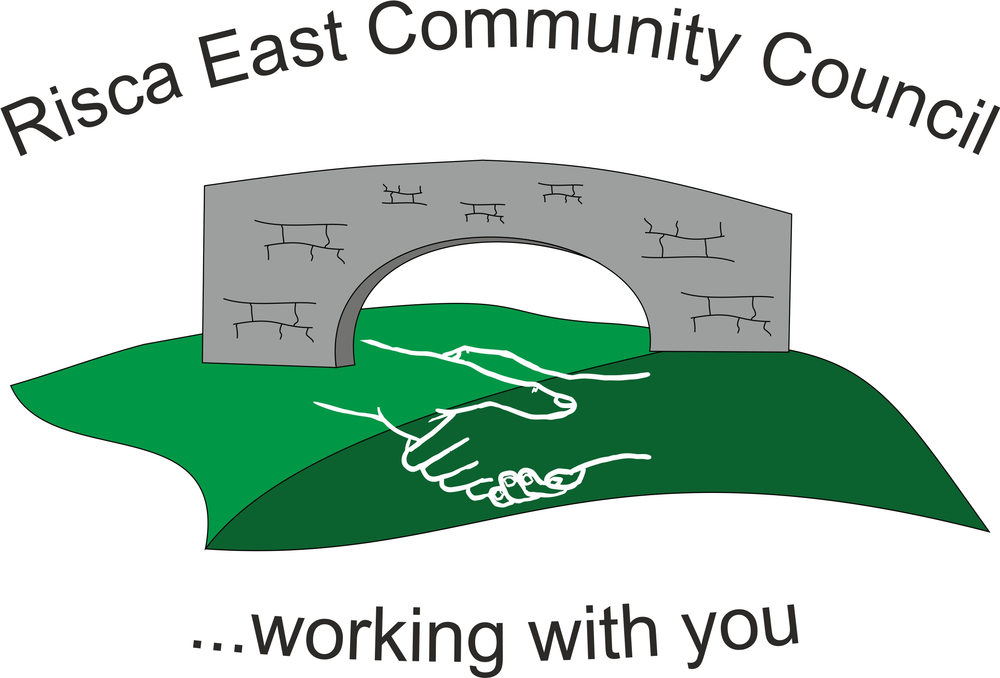 | Clerk/RFO Nicola Roberts  Village Farm  Manmoel  Blackwood  NP12 0RW  Tel. 07904 061754  www.riscaeastcc.org.uk  e-mail riscaeastcommunitycouncil@outlook.com
16-6-25 Meeting started 5:30 pm

6/25/1 Attendance and Apologies
To record attendance and receive apologies.
6/25/1.1 Community Councilors present – Councilors Zoe Davies, Nigel George, Roger Smith, Arriana Leonard, Philippa Leonard, Bernadette Martin, Vim Goraniya. Chair was Cllr Nigel George. Guest Stacey Murphy Evans

6/25/1.2 Apologies – Cllr Brandon Ham and Chris Thomas.

6/25/2 Minutes of the previous meeting
These were received as a true record Cllr Vim Goraniya proposed and Cllr Roger Smith seconded that the minutes were correct. The minutes for the AGM were also approved here.

6/25/3 Matters arising
There were no matter arising.

6/25/4 To receive the financial report from the Clerk
6/25/4.1 The clerk ran through the report and the proposed expenditure was agreed. Approval was given for the cheques itemised, the bank balance was £40,376.38.

- Financial report was accepted
- Committed spend –once the events cttee have estimated costs they will notify the clerk to include an estimate in the accounts. No invoice had yet been received by the lighting contractor.

6/25/5 Correspondence

6.25.5.1Tracey Murphy Evans was present to present the funding application for Ty Sign Family. A brief summary was given and the Committee asked numerous questions. Stacey Left the Room. Cllr Zoe Davies declared an interest and also left the meeting. A discussion was held and then voting was made. The decision was unanimous to approve the funding for £2,000. Stacey and Cllr Zoe Davies returned to the meeting and then once informed of the Committee’s decision Stacey Murphy Evans left the meeting.

6.25.5.2 An email was received off CVW requesting a donation for £1,000. Cllr P Leonard declared an interest in this and left the meeting. A discussion took place and then the vote was unanimous to donate £1,000. Cllr P Leonard returned to the meeting.
6.25.5.3 Risca Comprehensive Comprehensive PTA submitted a grant claim for £2,500. The application was discussed in detail and then the vote was unanimous to approve the claim.

6.25.5.4 Friends of TySign submitted and application form for funding for £500. Cllrs N George, Philippa Leonard and Arianna Leonard left the meeting after declaring an interest. The Committee discussed the application and voted unanimously to reject the application in this instance until they have seen some evidence of how the previous donations have been spent.

6/25/6 – Events –
6/25/6. A number of Events were under consideration for the benefit of the Community. A summer fayre is currently being organised and as soon as some firm costs are received they will be fed into the accounts as committed expenditure. So far the costs listed were expected to be: £250 for Characters, Animal interaction £300, First aider £105, Toilets £456, Punch and Judy £300, a new plinth for the electric box £98. Costs were still to be collected for a bouncy castle. There would also be a burger van, cheesecake van and ice cream van.

6/25/7 – To receive the report from Community Councillors
6/25/7. Risca East and Risca West are set to merge via the report from the Boundary Commission.
- Moriah Mews has been shut off for clearing works.
- Cleaning and Greening scheme – CCBC will remove the weeds and clear sites. Cllr N George to forward email Addresses.
- The LDP scheme has had some parcels of land added to it. Ecological testing will need to be carried out.

6/25/8 To discuss local issues raised by Councilors

CCBC will be clearing behind the shops. They will communicate in advance to cut growth back.

6/25/9 Planning Notifications
None

6/25/10 Any other business –

Cllr B Martin asked about the fencing around Ty Sign field. Insurance couldn’t be obtained, they will ask the Insurance of CCBC for advice.

The Clerk has notified the committee of her resignation. The post will be advertised for a replacement.

It was decided to have a summer pantomime either the 16/8/25 or 23/8/25.

Date of next meeting 10th July 2025 at 5.30 pm.

Meeting closed 19:02 pm

Signed……………………………………………………….Chairman 13th June 2025

