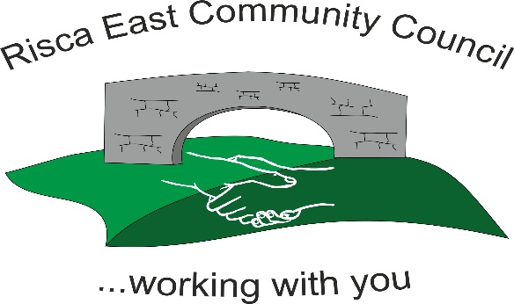 | Clerk/RFO Zoe Lovis Whitethorne Street  Crumlin  NP11 4PY  Tel. 07904 061754  www.riscaeastcc.org.uk  e-mail riscaeastcommunitycouncil@outlook.com
17-10-25 Meeting started 5:30 pm

10/25/1 Attendance and Apologies
To record attendance and receive apologies

10.25.1-1 Community Councilors present – Councilors; Chair Nigel George, Roger Smith Arriana Leonard, Philippa Leonard and Cllr Chris Thomas, Cllr Brandon Ham and Vim Goraniya.
10.25.1-2 Apologies received from Councilors Zoe Davies and Bernadette Martin

10/25/2 Minutes of the previous meeting
These were received as a true record and accepted by all Council members.

10/25/3 Matters arising
There were no matter arising.

10/25/4 To receive the financial report from the Clerk
10.25.4-1 The clerk ran through the report and the proposed expenditure was agreed. Approval was given for the cheques itemised, the bank balance was £38,843.19.

- Financial report was accepted
- Committed spend –events committee have estimated costs for Christmas lighting to be updated in the accounts.

10/25/5 Correspondence

10.25.5-1 Thank you letter was received from St David’s Hospice Care for donation of £500.
10.25.5-2 Donation request from Hope dog rescue received. £100 was agreed by all Cllrs to be donated.
10.25.5-3 Donation request from Community Volunteer Wales for funding. 1 Cllr refrained from voting due to interest. 5/6 of Cllrs approved request and donation of £2042 granted.
10.25.5-4 Enquires from companies about work availability. Discussed and Cllrs unanimously agreed not required at present.
10.25.5-5 Queries from members of community discussed and to be personally responded to.
10.25.5-6 Works at Pontymister Industrial Estate were discussed. No comments or concerns from Cllrs.
10.25.5-7 Grant application received from Friends of Ty Sign Primary School to replace unsafe play area. Funding required for £1800 was approved. 4 Cllrs had conflict of interest and refrained from voting. Agreed by all of 3 remaining Cllrs.
10.25.5-8 Funding request from GAVO which was declined by all Cllrs at this time.
10.25.5-9 Funding application from TLC Risca for various community benefits. Cllrs in unanimous agreement. Funding approved for £1400.50.

10/25/6 – Events

10.25.6-1 Cllr C Thomas discussed Greenleif meeting who is sourcing Christmas lights and decorations estimated and £6,000-£10,000. Extra lampposts to be included. Additional improvement for tree. New lights. All Cllrs in agreement for works to go ahead. Further discussion to take place with Greenleif on more details.
10.25.6-2 The poppies for remembrance Sunday to be mounted by Cllrs themselves 18/10/25.
10.25.6-3 Arrangements for the Pantomime are still in ongoing discussions.
10.25.6-4 Posters for Christmas events to be printed and shared.
10.25.6-5 Next events committee will take place on 03.11.25 at 5.30pm.

10/25/7 – To receive the report from County Borough Councillors

10.25.7-1 Cllr Phillipa Leonard discussed the LDP push back due to viability checks. CCBC are doing all they can to avoid but the checks are required. Proposed date to be June 2026 for seminars for wards and for public consultations 2027.
10.25.7-2 Greener and Cleaner Scheme. Cllrs still contacting parks for grass cutting around Elm Drive.

10/25/8 To discuss local issues raised by Councilors

10.25.8-1 The rail for around Ty Sign park proposed to start 10/11/25.
10.25.8-2 Notice Board to be put in the community- where is to be arranged.
10.25.8-3 Discussions to take place on the potential to put Christmas lights around manor way next year.

10/25/9 Planning Notifications
None

10/25/10 Any other business –
None

Date of next meeting 19th November 2025 at 5.30 pm.

Meeting closed 19:00 pm

Signed………………………………………………………Chairman 17th November 2025

