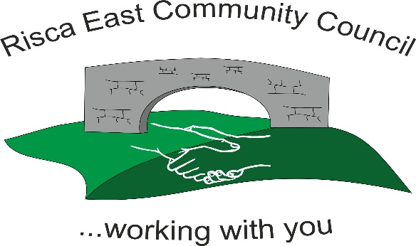 | Clerk/RFO Zoe Lovis Whitethorne Street  Crumlin  NP11 4PY  Tel. 07904 061754  www.riscaeastcc.org.uk  e-mail riscaeastcommunitycouncil@outlook.com
12-12-25 Meeting started 5:30 pm

12/25/1 Attendance and Apologies
To record attendance and receive apologies

12.25.1-1 Community Councilors present –, Roger Smith, Arriana Leonard, Philippa Leonard and Cllr Chris Thomas, Cllr Brandon Ham and Vim Goraniya. Zoe Davies and Bernadette Martin
12.25.1-2 Apologies - Councilors; Chair Nigel George

12/25/2 Minutes of the previous meeting
These were received as a true record and accepted by all Council members.
12.25.2-1 The fence at Ty Sign Park has been requoted at £10,000 not the previous £8479. This was accepted by Cllrs.

12/25/3 Matters arising
12.25.3-1 Notice boards discussed- will be ongoing in new year.

12/25/4 To receive the financial report from the Clerk
12.25.4-1 The clerk ran through the report and the proposed expenditure was agreed. Approval was given for the cheques itemized. The bank balance is £33,982.36 as at todays meeting.

- Financial report was accepted
- Committed spend – Panto required spends discussed

12/25/5 Correspondence

12.25.5-1 Letter of thanks from Risca Museum Membership for Risca East Support.
12.25.5-2 Correspondence and contact from residents was discussed and Cllrs will look into concerns and contact residents shortly with updates.

12/25/6 – Events

12.25.6-1 Upcoming Panto arrangements for 19/12/25 - Cllrs volunteered to assist in the set-up, tickets still available, goody bags for children, rental for hall. Previous issues (toilets) will be managed ensuring site is fully useable. Sub committee members have purchased all required supplies for event.

12/25/7 – To receive the report from County Borough Councillors

12.25.7-1 – Pride and Place Impact Fund was raised and discussed by local Cllrs- encouragement for any community groups to apply for the financial support by 19/12/25.
12.25.7-2- Homelessness Prevention Schemes discussed. Young people aged 16-24 leaving care and education systems who may become homeless. People who are able to open up their homes i.e. spare rooms; without guardianship to support in transitioning.

12/25/8 To discuss local issues raised by Councilors

12.25.8-1 The damage at Ty Sign Park was raised highlight the need for a fence. CCTV footage of the damage is to be requested.
12.25.8-2 Festive lighting discussed. Cllrs and residents pleased with the new tree and lights.

12/25/9 Planning Notifications
None

12/25/10 Any other business –
12.25.10.1 Spare selection boxes from events have been donated to TLC for their upcoming festive events.
12.25.10-2 Repairs for tree to be looked into.

Date of next meeting 9th January 2025 at 5.30 pm.

Meeting closed 18:45 pm

Signed………………………………………………………Chairman 12th December 2025

