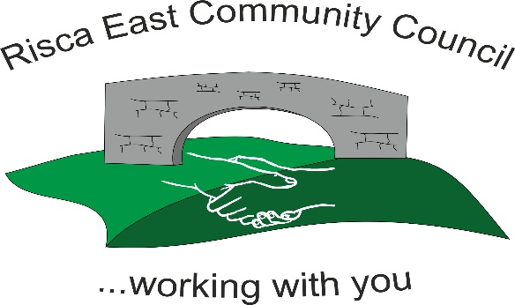 | Clerk/RFO Zoe Lovis Whitethorne Street  Crumlin  NP11 4PY  Tel. 07904 061754  www.riscaeastcc.org.uk  e-mail riscaeastcommunitycouncil@outlook.com
14-11-25 Meeting started 5:30 pm

11/25/1 Attendance and Apologies
To record attendance and receive apologies

11.25.1-1 Community Councilors present – Councilors; Chair Nigel George, Roger Smith Arriana Leonard, Philippa Leonard and Cllr Chris Thomas, Cllr Brandon Ham and Vim Goraniya. Zoe Davies and Bernadette Martin
11.25.1-2 Apologies - None

11/25/2 Minutes of the previous meeting
These were received as a true record and accepted by all Council members.

11/25/3 Matters arising
There were no matter arising.

11/25/4 To receive the financial report from the Clerk
11.25.4-1 The clerk ran through the report and the proposed expenditure was agreed. Approval was given for the cheques itemised, the bank balance was £36,525.03.

- Financial report was accepted
- Committed spend – hire of hall, selection boxes and childrens treats to be added for Panto

11/25/5 Correspondence

11.25.5-1 Donation request for new tables and chairs at TLC. Discussions took place regarding the benefits for the community and support for locally well used establishment and approved by all Cllrs (1 Cllr refrained from voting due to interest) £2829.20.
11.25.5-2 Donation to Ty Sign Primary School for selection boxes £300.
11.25.5-3 Provision for secure email domains discussed and agreed by all Cllrs.
11.25.5-4 Information Commissioners Fee and Town Council fees to be paid

11/25/6 – Events

11.25.6-1 Discussion regarding Greenleif and Christmas lights noted that there are ongoing issues regarding certification between Greenleif and CCBC delaying approval for lighting. Cllrs continuing to follow up. Agreed if lighting problems continue and unable to switch on, activities including santa, brass band and festive activities will continue as planned as the TLC.
11.25.6-2 Events meeting took place to discuss and plan arrangements for the upcoming Christmas events and activities.
11.25.6-3 Local flooding concerns discussed, no issues reported locally
11.25.6-4 Risca Decides event at Risca Rugby Club discussed and support given from Cllrs
11.25.6-5 Poppies to be taken down from streets in Risca East by Cllrs and supporters

11/25/7 – To receive the report from County Borough Councillors

11.25.7-1 – Discussion took place and updates given regarding new leaders, deputies and cabinet members at CCBC.

11/25/8 To discuss local issues raised by Councilors

11.25.8-1 Fencing around Ty Sign community park is in discussion and agreed £8476.19
11.25.8-2 Letter to be sent to Boundary Commission in regards to concerns raised with the merging of Risca Town and Risca East Community Councils and its impact on the local residents in Risca East and the community. This was agreed by, and is to be signed by, 8/9 Cllrs.
11.25.8-3 New notice boards were discussed and is in ongoing enquiries
11.25.8-4 Placing bench at Hafod Y Bryn Park discussed. Ongoing enquiries

11/25/9 Planning Notifications

11/25/9.1 Planning application 25/0698/RET- Maesmawr Farm Mountain Road discussed, no concerns raised.

11/25/10 Any other business –
11/25/10.1 Precept for January was discussed and expected figures

Date of next meeting 12th December 2025 at 5.30 pm.

Meeting closed 18:45 pm

Signed………………………………………………………Chairman 17th November 2025

