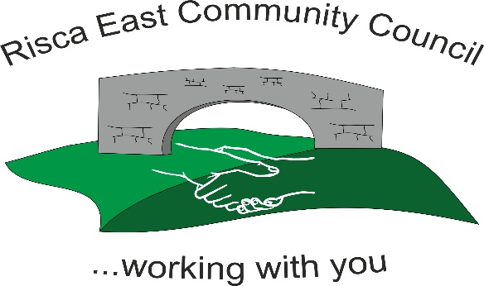 | Clerk/RFO Zoe Lovis Whitethorne Street  Crumlin  NP11 4PY  Tel. 07904 061754  www.riscaeastcc.org.uk  e-mail riscaeastcommunitycouncil@outlook.com
09-01-25 Meeting started 5:30 pm

01/26/1 Attendance and Apologies
To record attendance and receive apologies

01.26.1-1 Community Councilors present –, Roger Smith, Arriana Leonard, Philippa Leonard and Cllr Chris Thomas, Cllr Brandon Ham, Vim Goraniya, Zoe Davies, Bernadette Martin
01.26.1-2 Apologies - Councilors; Chair Nigel George

01/26/2 Minutes of the previous meeting
These were received as a true record and accepted by all Council members.

01/26/3 Matters arising
01.26.3-1 Notice Boards discussed. Various boards to be either moved, replaced and new to be added. Awaiting permissions and quotes to be gained. Discussed making them more presentable and accessible for all residents to increase viewing.
01.26.3-2 The damage to the oak tree was discussed. Cllrs to investigate repair and rescue.
01.26.3-3 Fence work delayed- will be chased up by Cllr to start shortly.

01/26/4 To receive the financial report from the Clerk
01.26.4-1 The clerk ran through the report and the proposed expenditure was agreed. Approval was given for the cheques itemized. The bank balance is £33,982.36 as at todays meeting.

- Financial report was accepted
- Committed spend discussed

01/26/5 Correspondence

01.26.5-1. Discussions took place regarding the concerns from residents being targeted and misquoted for works and repairs. Residents should be aware of risks of financial fraud and pass concerns to local authorities.
01.26.5-2. The 26/27 precept is required for submission. Concerns discussed regarding the impact of precept changes on residents affordability vs the impact on the community.
This was discussed between Cllrs and decision taken to a vote. It was agreed that precept would remain at £17 by 4/7 Cllrs.

01/26/6 – Events

01.26.6-1 Christmas events discussed and Cllrs and residents pleased with outcome.
01.26.6-2 2026 events discussed including parties and fetes and will be organized in an events meeting to take place Thursday 22nd January at Channel View Community Centre.

01/26/7 – To receive the report from County Borough Councillors

01.26.7-1- Local Cllr discussed the upcoming budget meeting at CCBC 12/01/26.
01.26.7-2 – Cllr discussed CCBC ‘Cleaner and Greener’ scheme. Residents to report concerns.

01/26/8 To discuss local issues raised by Councilors

01.26.8-1 Standards committee voting process was discussed and to be investigated.
01.26.8-2 Overuse of Rowan Park, community park by cars discussed. Signs required to highlight no access / emergency vehicles or access only.

01/26/9 Planning Notifications
None

01/26/10 Any other business –
01.26.10-1 Audit fees discussed, to be investigated by clerk
01.26.10-2 The purchase of a marquee and sound systems for future events is being looked into. Quotes to be gathered and storage investigated.
01.26.10-3 Lights for Hafod Y Bryn to be investigated.
01.26.10-4 Concerns from residents regarding littering, dog fouling and overflowing bins. Cllrs to investigate additional bins, monitoring and use of additional signs. To be discussed with CCBC. Areas of concern discussed – Almond Avenue, bins being filled overnight.

Date of next meeting 13th February 2026 at 5.30 pm.

Meeting closed 19:15 pm

Signed………………………………………………………Chairman 12th December 2025

