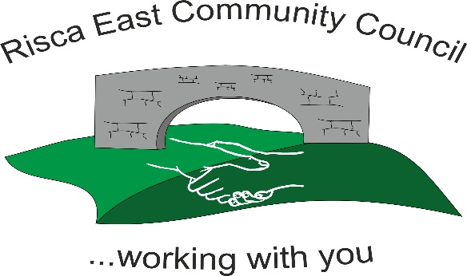
Handling employee grievances
The ACAS Code of Practice on disciplinary and grievance procedures contains recommendations on handling grievances for both employers and employees. The Code defines grievances as "concerns, problems or complaints that employees raise with their employers".

- Grievances should, wherever possible, be dealt with informally by the employee's designated manager. However, the procedure in place should allow employees to raise grievances with someone other than their own designated manager - in case the designated manager is the subject of the grievance.
- Ensure grievances are tackled promptly (although not in haste), with investigations being carried out as appropriate
- Grievances should be viewed constructively, as a complaint may enable a workplace problem to be identified and resolved
- Make sure that no employee suffers recrimination as a result of raising a genuine grievance
- When a written, or otherwise formal, grievance is received, arrange for a formal grievance hearing to be held without unreasonable delay
- Inform the employee that they have the right to be accompanied by a colleague or trade union representative of his/her choice at any formal grievance hearing (or appeal hearing)
- At a hearing, allow the employee to explain the grievance and how he or she thinks it should be resolved
- Ensure that managers/councillors hearing grievances are willing to listen to what the employee has to say and seek to resolve the matter in a way that is satisfactory to the employee wherever possible
- It is generally a good idea to ask the employee at the outset what outcome he or she wants, then consider whether this is deliverable
- Adjourn the meeting to allow for any further investigation that is deemed necessary
- After the meeting (and following any further necessary investigation), decide what action, if any, should be taken
- Communicate the decision to the employee in writing as soon as possible after the grievance hearing
- It is important to always give the employee feedback on the decision taken, even if the decision is that nothing can be done to resolve the grievance or to change matters. The employee has a right to receive a response to the grievance, even if it is not the response he or she would have wanted
- Inform the employee that they have the right to appeal if they feel that the grievance has not been satisfactorily dealt with or resolved
- Hear appeals without unreasonable delay
- Arrange for an appeal to be dealt with impartially by a designated Panel of Councillors who have not previously been involved in the case
- Communicate the outcome of the appeal to the employee in writing without unreasonable delay
- Where appropriate, send out a letter that states the matter is now closed and there is no further right of appeal (the ACAS Code requires only one level of appeal following a grievance)
- Confidentiality should be respected throughout the process of handling employees' grievances
- Where an employee has a grievance that relates to a disciplinary sanction, s/he should not use the employer's grievance procedure, but instead raise an appeal under the disciplinary procedure

Councils should ensure that they look to establish a Committee or Panel of Councillors to hear the grievance and have in place a separate Committee or Panel to deal with appeals.

