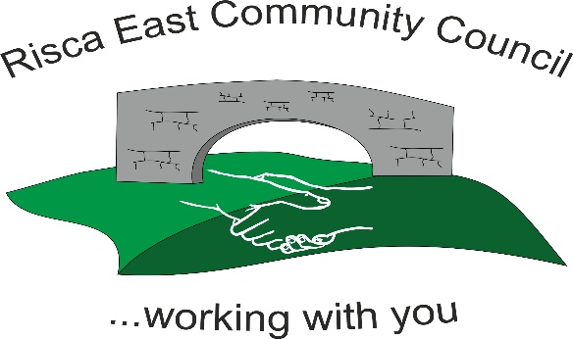 | Clerk/RFO Zoe Lovis Whitethorne Street  Crumlin  NP11 4PY  Tel. 07904 061754  www.riscaeastcc.org.uk  e-mail riscaeastcommunitycouncil@outlook.com
13-02-25 Meeting started at 5:30 pm.

02/26/1 Attendance and Apologies

To record attendance and receive apologies.

02.26.1-1 Community Councilors present – Roger Smith, Arriana Leonard, Philippa Leonard, Chris Thomas, Brandon Ham, Vim Goraniya, Zoe Davies, Bernadette Martin
02.26.1-2 Apologies - Councilors; Chair Nigel George

02/26/2 Minutes of the previous meeting

02.26.2-1 Accepted as true by Cllrs

02/26/3 Matters arising

02.26.3-1- January 2026 minutes- attendance to be amended as VG was not in attendance.
02.26.3-3- Notice boards discussed and are discussions are still ongoing with the authority

02/26/4 To receive the financial report from the Clerk

02.26.4-1 The clerk ran through the report and the proposed expenditure was agreed.
- Christmas lighting
- RECC Insurance Renewal
- SLCC renewal
Approval was given for the itemized cheques. The bank balance is £27,065.17 as at today’s meeting.

- Financial statements were reviewed, queries discussed and resolved and accepted by Cllrs.
- Committed spend.
02.26.4-2 Online banking has been pursued and is currently being set up.

02/26/5 Correspondence

02.26.5-1. Cllrs have been in contact with fencing contractors as concerns raised. This is being investigated on an ongoing basis.
02.26.5-2. Contact from Marie Curie charity regarding donations to help their causes - £200 to be given from Risca East for supporting charities.
02.26.5-3 Email regarding the development of play areas was discussed and more information to be gathered on pricing and the benefits to the community
02.26.5-4 Contact from company regarding bike stunt show was discussed and information to be gathered for potential community events.

02/26/6 – Subcommittees

- Events - Updates given from events meeting.
02.26.6-1 Schedule and calendar in use to attempt that any events planned by RECC not to conflict with other establishments events in the area.
02.26.6-2 Summer fete proposed for 15th August. Singer, shows and entertainment discussed are arrangements to be begin.
02.26.6-3 Animal experience and animal theme event being investigated for may half term- dates to be confirmed. Potentially online booking to ensure numbers for event with up to 3 sessions available. Health and Safety concerns discussed and to be fully investigated before decisions made.
02.26.6-4 Following discussions, quotations and investigations of gazebos for the use at RECC events it was unanimously agreed by Cllrs to go ahead with purchase at estimated £6640 for two.
02.26.6-5 The purchase of a sound system was unanimously agreed by all Cllrs for the use at all events planned. Estimated £230.
02.26.6-6 The purchase of a generator is being investigated for use at future events. Purchase of equipment will save future hire costs.
02.26.6-7 Locations of events was discussed. Channel view and Sycamore Centre discussed- to be confirmed.

02/26/7 – To receive the report from County Borough Councilors

02.26.7-1- Lighting concerns under the railway at Channel View have been brough to attention of Cllrs who are now dealing.
02.26.7-2 – Cllr discussed CCBC ‘Cleaner and Greener’ scheme- they have taken photos around the community of areas requiring improvement and have been sent to the project. This involved many areas and streets around Risca East. Concerns regarding overgrown bushes and moss are to be addressed.
02.26.7-3 – Lanes at Holly Road need clearing as issues with rubbish which Cllrs are reporting to be dealt with.
02.26.7-4 Cllrs informed that residents could request street sweeping at any time directly though CCBC.
02.26.7-5 Parking concerns at Herbert Avenue are to be reported.
02.26.7-6 Abandoned vehicle and rubbish left have been reported to Westbury Homes who are investigating.
02.26.7-7 A site meeting with a housing officer has taken place to rectify problems at Elm drive with the overgrown bushes pushing back fences.

02/26/8 To discuss local issues raised by Councilors

No issues raised.

02/26/9 Planning Notifications
02.26.09-1 Extension proposal at Chiltern Close was discussed - no objections

02/26/10 Any other business –

02.26.10-1 Audit outcome discussed and resolutions to be examined by clerk
02.26.10-2 Signage for Ty Sign Community Park being arranged

Date of next meeting 13th March 2026 at 5.30 pm.

Meeting closed 19:15 pm

Signed………………………………………………………Chairman 13th March 2026

