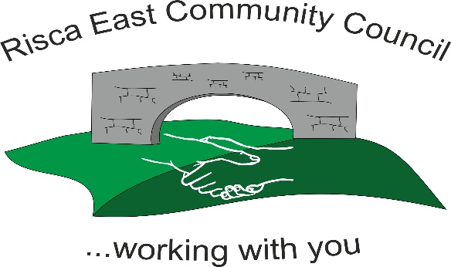 | Clerk/RFO Zoe Lovis Whitethorne Street  Crumlin  NP11 4PY  Tel. 07904 061754  www.riscaeastcc.org.uk  e-mail riscaeastcommunitycouncil@outlook.com
13-03-25 Meeting started at 5:30 pm.

03/26/1 Attendance and Apologies

To record attendance and receive apologies.

03.26.1-1 Community Councilors present – Roger Smith, Arriana Leonard, Philippa Leonard, Chris Thomas, Brandon Ham, Vim Goraniya, Zoe Davies, Bernadette Martin
03.26.1-2 Apologies - Councilors; Chair Nigel George
Cllr Chris Thomas left mid meeting

03/26/2 Minutes of the previous meeting

03.26.2-1 Accepted as true by Cllrs

03/26/3 Matters arising

03.26.3-1- Fencing around park was discussed along with issues with completion. Cllrs are dealing with resolutions.
03.26.3-2 2 Marquees are to be purchased at a cost of £6500 for all events. Storage was discussed and to be arranged before ordering.

03/26/4 To receive the financial report from the Clerk

03.26.4-1 The clerk ran through the report and the proposed expenditure was agreed. The bank balance is £26924.77 as at today’s meeting.
Approval was given for the itemized cheques.

13-Mar-2026 | 100792 | VG | selection boxes- Christmas party | £358.20
13-Mar-2026 | 100793 | Community Volunteers Wales | property valuation donation | £1,350.00
13-Mar-2026 | 100794 | United Graphic Design | Website maintenance | £199.62
13-Mar-2026 | 100795 | HCTP Group 99 | Donation | £1400
13-Mar-2026 | 100796 | ZL | Payslip March | £395.55
13-Mar-2026 | 100797 | ZL | Phone bill February and March | £10
13-Mar-2026 | 100799 | SLCC | Membership renewal | £84

- Financial statements were reviewed, queries discussed and resolved and accepted by Cllrs.
- Committed spend reviewed

03/26/5 Correspondence

03.26.5-1. Cllrs discussed a request for benches around the skate park. This is to be considered by Cllrs in next financial year.
03.26.5-2. Visit from HCPT charity who discussed their work with children and families. They asked for support in form of a donation so they can give children experiences including holidays they may not otherwise have opportunities for. This affects children in our local community and was discussed between Cllrs how support could benefit many local families. £1400 was unanimously agreed by all Cllrs to be donated.
03.26.5-3 Application from Community Volunteers Wales for funds to have a survey on a building they are purchasing. They have received a grant from the UK Government funded by Pride in Place to purchase the building but not enough to cover the survey which is necessary for the purchase to take place. Cllrs discussed all the benefits that they bring to the community. A vote took place. 1 Cllr refrained from voting due to personal interest. Of 6 Cllrs present 6 agreed the donation.

03/26/6 – Subcommittees

- Events - Updates given from events meeting that took place 5th March. It was discussed that Cllrs wanted to use different local establishments and create events for all age groups and abilities. All plans were agreed by Cllrs at full meeting and will now begin booking and arranging.

03.26.6-1 Spring event during May Half term at Channel View community Centre for children and families tbc. Food options in discussion.
03.26.6-2 Summer event at Ty Darren has been enquired tbc potential tea party theme
03.26.6-3 Summer fete on the field 15th August 2026 (Subject to confirmation) with a variety of entertainment and stalls. Food options discussed, as last year the burger van was seen as expensive. Further options under investigation by Cllrs.
03.26.6-4 Skating event at Risca Leisure Centre in discussion for older children. October half term (Subject to confirmation)
03.26.6-5 Christmas Pantomime and TLC for the grotto 5th December 2026 (Subject to confirmation)
03.26.6-6 Christmas party and Santa visit 12th December 2026 (Subject to confirmation)

03/26/7 – To receive the report from County Borough Councilors

03.26.7-1- The joining of Risca East Community Council and Risca Town Council was discussed and more updates to be given as agreed. Clerk to arrange meeting to discuss arrangements.
03.26.7-2 – Cllrs discussed CCBC ‘Cleaner and Greener’ scheme encouraging any residents to contact if any areas needing cleaning, sweeping or cutting back
03.26.7-3 – Ty Sign Primary are in need of funding as there is much needed work that needs completion to improve the school grounds.
03.26.7-4 Ty Darren is now open as of March 2026 and council will be looking at housing register to fill all flats.
.

03/26/8 To discuss local issues raised by Councilors

03.26.8-1 CCTV issues discussed in the community especially camera around Ty Sign Park.

03/26/9 Planning Notifications
03.26.09-1 Extension proposal at Pentland Close was discussed - no objections

03/26/10 Any other business –

03.26.10-1

Date of next meeting Friday 11th April 2026 at 5.30 pm.
AGM Meeting Friday 11th April 2026 5pm.

Meeting closed 19:15 pm

Signed………………………………………………………Chairman 11th April 2026

