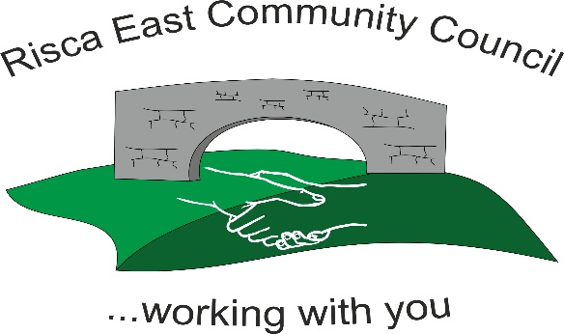 | Clerk/RFO Zoe Lovis Whitethorne Street  Crumlin  NP11 4PY  Tel. 07904 061754  www.riscaeastcc.org.uk  e-mail riscaeastcommunitycouncil@outlook.com

10-04-26 Meeting started at 5:15 pm

04/26/1 Attendance and Apologies
To record attendance and receive apologies.
04.26.1-1 Community Councilors present –Chair Brandon Ham and Cllrs Roger Smith, Arriana Leonard, Philippa Leonard and Christine Thomas, Zoe Davies, and Bernadette Martin.
04.26.1-2 Apologies - Councilors; Nigel George, Vim Goraniya

04/26/2 Minutes of the previous meeting
04.26.2-1 Accepted as true by Cllrs. Proposed by AL, seconded by PL.

04/26/3 Matters arising
04.26.3-1- March 2026 minutes were reviewed and updates regarding the fencing of the park was discussed. The contractor has been contacted and work reviewed by a CCBC surveyor who has approved. It is hoped work will be shortly completed.
04.26.3- Notice boards discussed and discussions are still ongoing.
04.26.3-4- Placement of signs around Ty Sign Park were discussed and Cllr CT will contact for quotes. Designs for the signs were discussed and the need for bilingual signs. Two signs will be quoted for.
04.26.3-5 Cllr’s discussed the damaged Oak tree, and a replacement is being investigated.
04.26.3-6 The storage of the marquee that is due to be purchased was discussed and Cllrs are looking into garage rental for ease of access for events. PL to enquire.

04/26/4 To receive the financial report from the Clerk
04.26.4-1 The clerk ran through the report and the proposed expenditure was agreed by Cllr’s. Approval was given for the itemized cheques. The bank balance is £11,158.69 as at today’s meeting.
£6000 is allocated for marquees.
£200 for a speaker for events
£800 estimated as storage fees
- Financial statements and invoices were reviewed, discussed, and accepted by Cllrs.
- Budget was discussed and a budget review meeting set for 8th May 2026

10/04/2024 | SLCC membership | 100805 | £114

04/26/5 Correspondence
04.26.5-1 Various national requests for donations were received and discussed; however, it was decided that at present until further funding is received local causes will be priority.
Community.
04.26.5-2 Email from CCBC requesting comments on the addition and removal of disabled comments. No comments or objections from Cllr’s

04/26/6 – Subcommittees
- Events
04.26.6-1 The Animal Encounter event has been confirmed to take place for 27th May 12-4pm. This will be limited to 90 children due to the animal’s needs- 3 sessions with 30 children per session which is to be prebooked. Soft play has been reserved, and a treat box is to be provided. This will take place at Channel View Community Centre and the scouts hall. Funding and costing were discussed and approved by all Cllrs.
04.26.6-2 A summer event at Ty Darren has been suggested for 4th July (subject to change) from 12-3pm. Quotes are being gathered for food to be provided (BM) and entertainment being sourced (CT). Numbers are being gathered for the event and depending on availability and transport, Hafod Y Bryn may be offered to attend.

04/26/7 – To receive the report from County Borough Councilor’s
04.26.7-1- CCBC Cllr’s have had no updates to discuss.

04/26/8 To discuss local issues raised by Councilors
04.26.8-1 Reports of local antisocial behaviour were discussed by Cllr’s.
04.26.8-2 Cllr BM received letter querying actions from CCBCs cleaner and greener scheme. It was discussed that if there are any concerns over overgrown areas that need attention, residents should contact CCBC or RECC.
04.26.8-3 The pathway from Snowden to Eppynt was discussed. If residents have concerns over the blocked path, they are to contact Cllr Phillipa Leonard or RECC

04/26/9 Planning Notifications
None received.

04/26/10 Any other business –
04.26.10-1 A meeting has taken place within Safer Communities, after a request was received for noticeboards in the flats at Holly Road so residents can be kept informed of events and have ease of access to information and contact information. Cllrs discussed it, and an application needs to be sent detailing what is required to apply for funding.
04.26.10-2 It was discussed that the precept at RECC was not increased. There have been a lot of donations made to support local businesses and events arranged for residents that will be advertised so residents are aware of where the money is being spent.
04.26.10-3 GDPR regulations to be investigated by clerk.

Date of next meeting 8th May 2026 at 5.30 pm.

Meeting closed 19:15 pm

Signed………………………………………………………Chairman 8th May 2026

