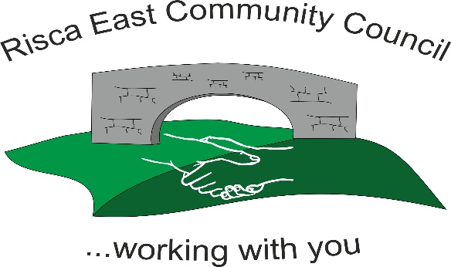 | Clerk/RFO Zoe Lovis 9 Whitethorne Street  Crumlin  NP11 4PY  Tel. 07904 061754  www.riscaeastcc.org.uk  e-mail: riscaeastcommunitycouncil@outlook.com

08-05-26 Meeting started at 5:30 pm

05/26/1 Attendance and Apologies
To record attendance and receive apologies.
05.26.1-1 Community Councilors present – Chair Brandon Ham and Cllrs- Roger Smith, and Christine Thomas, Zoe Davies, Vim Goraniya. Arianna Leonard attended but left early.
05.26.1-2 Apologies - Councilors; Nigel George, Philippa Leonard, Bernadette Martin

05/26/2 Minutes of the previous meeting
04.26.2-1 Accepted as true by Cllrs. Proposed by AL, seconded by ZD.

05/26/3 Matters arising
05.26.3-1- No matters discussed.

05/26/4 To receive the financial report from the Clerk
05.26.4-1 The clerk ran through the report, and the proposed expenditure was agreed by Cllr’s. Approval was given for the itemized cheques.
First installment of precept has been received and bring the bank balance to £27,000 as at today’s meeting.

- Financial statements and invoices were reviewed, discussed, and accepted by Cllrs.
08/05/2024 | 100809 | Notice Boards | £1130
08/05/2024 | 100810 | Animal Encounter event | £427
08/05/2024 | 100811 | Soft play | £250

- 2026/27 budget was discussed and agreed by Cllrs subject to regular review as attached. It was agreed that clerk hours would increase from 8 to 11 hours per week in line with other community councils. This increases costs by £1600 per year excluding tax.
- Audit Wales have contacted clerk to advise that a basic audit is to be completed by June 30th. In preparation for this an internal audit is to be completed in May at a cost of £200.

05/26/5 Correspondence
05.26.5-1 Residents have raised concerns regarding the condition of the noticeboards. The Chair has reviewed all noticeboards for safety and quality checks and has locked damaged ones for security. Cllrs discussed concerns about them not being fit for purpose and it was proposed that several in poor condition be removed and one new one to be purchased and placed centrally at shop. It is to be regularly checked for upkeep and maintenance. This was unanimously agreed between Cllrs for £1130 for the removal of notice board and fitting of a more adequate one.
05.26.5-2 Fly tipping was another concern raised which all Cllrs are working on monitoring to stop it continuing with support from CCBC.
05.26.5-3 Further contact from residents raised concerns over website and council spending transparency. Going forward minutes will be put onto the website within 7 days, placed on the notice board shortly after and emails responded to within 5-7 working days. Regular budget monitoring will be transparent for all residents.
05.26.5-4 Cllrs reached out to local businesses for quotes to provide food for children at the upcoming Animal Encounter event. Only one received from TLC for £404 which has been accepted. They will deliver the snack boxes 12pm on day of event.
05.26.5-5 Application from Ty Sign Families for a funded trip to Legoland for local families was received for £2162. This was discussed between Cllrs and as Ty Sign Families have also applied for other funding, the decision will be made when results from other funding for the trip is received. Cllrs agreed that they will donate if funding from another source is refused and if accepted, will contribute to other costs the trip may incur.
05.26.5-6 Application for funding received from Able Roots CIC for equipment to support their cause. Clerk is to contact then to find out more information as Cllrs aim to support local community first.

05/26/6 – Subcommittees
- Events
05.26.6-1 The Animal Encounter 27th May 12-4pm has proved popular and tickets are now sold out. Soft play has been booked, and a treat box for each child has been arranged. This will take place at Channel View Community Centre and the scouts hall. Event costings are £1080 at present and free for community.

05/26/7 – To receive the report from County Borough Councilor’s
05.26.7-1- CCBC Cllr’s gave apologies for the meeting.

05/26/8 To discuss local issues raised by Councilors
05.26.8-1 Fencing around the park is complete and has been signed off and approved by CCBC.
05.26.8-2 Signs for Ty Sign Community Park were discussed, and Cllrs will gather quotes for next meeting. It was discussed that there is a lot of parking on the field so a sign stating ‘emergency vehicles only’ is in discussion.

05/26/9 Planning Notifications
None received.

05/26/10 Any other business –
05.26.10-1 Chair B Ham expressed thanks to N George and Z Davies for their service as Chair and Vice to date and looks forward to further working them in the upcoming year.
05.26.10-2 A resignation was received from Cllr B Martin. Chair offered best wishes for all the work she has done and will have further conversations to see if there is any support required before advertising a vacancy.
05.26.10-3 Meeting dates for the rest of the year were discussed and will be as follows.
- Friday 5th June
- Friday 3rd July
- Friday 7th August
- Friday 4th September
- Friday 2nd October
- Friday 6th November
- Friday 4th December
Further events meetings to be arranged.

Date of next meeting 5th June 2026 at 5.30 pm.

Meeting closes at 18:45 pm

Signed………………………………………………………Chairman 5th June 2026

