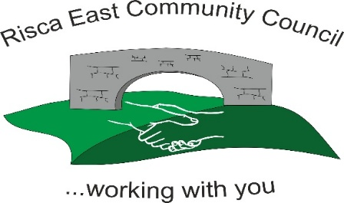 | Clerk/RFO Zoe Lovis 9 Whitethorne Street  Crumlin  NP11 4PY  Tel. 07904 061754  www.riscaeastcc.org.uk  e-mail: riscaeastcommunitycouncil@outlook.com

Risca East Community Council Annual Report 31 March 2025

Introduction
On behalf of Risca East Community Council, I am pleased to present our Annual Report for the financial year 2025/2026.
Throughout the year, the Council has continued to invest in community events, local charities, environmental improvements, and services that enhance the quality of life for residents. The Council remains committed to ensuring that public funds are used responsibly and effectively to support our community.
The Council would like to thank all residents for their continued support through the community precept. Your contribution helps us deliver valuable projects, events, and initiatives that benefit the whole community.
Community Precept
The Council's precept equates to approximately £17 per month per household. This funding enables the Council to support local events, community organisations, charities, and improvement projects across Risca East.
Financial Summary 2025/2026
During the financial year, the Council invested a total of £56,000 in improving and supporting the local community.
Expenditure Category | Amount (£)
Summer Fete | 2,500
Donations to Local Groups and Charities | 17,000
Christmas Lights | 17,000
Christmas Events | 1,500
Poppy Day Commemorations | 550
Outdoor Improvements | 8,000
Clerk's Salary and Expenses | 4,500
Stationery and Office Costs | 450
Memberships, Insurance and Training | 2,600
Councillors' Allowances | 900
Miscellaneous Expenditure | 1,000

Highlights of the Year
- Delivered a successful Summer Fete for local residents and families.
- Provided significant financial support to local charities and community organisations.
- Funded and maintained Christmas Lights throughout the community.
- Organised seasonal Christmas events for residents.
- Supported local remembrance activities through Poppy Day commemorations.
- Invested in outdoor improvements to enhance community spaces.
- Ensured effective administration and governance through staff support, training, insurance, and membership of relevant bodies.
Looking Ahead
The Council is currently developing plans and priorities for the 2026/2027 financial year. Further information on upcoming projects, events, and community initiatives will be announced shortly.
We look forward to continuing to work with residents, community groups, and local partners to make Risca East a thriving and welcoming community for all.
Acknowledgements
Risca East Community Council would like to thank residents, volunteers, community organisations, and local businesses for their ongoing support and contribution throughout the year.
Together, we continue to strengthen and improve our community.

Risca East Community Council
Summary Accounts 2025/26
Opening Balance as at 01/04/25 |  | 31,888.80
Expenditure
Salary | 4,431.09
Printing & Stationery | 487.38
Postage | 14.05
Council Phone | 59.13
Tax | 1,131.42
Donations | 17,121.70
Affiliations | 0.00
Equipment | 0.00
Chairman's Allowance | 0.00
Councillors' Allowances | 900.00
Insurance | 378.40
Audit Fee | 200.00
Room Use | 0.00
Panto | 761.01
Christmas Lights | 17,784.69
Website | 365.97
Newsletter | 0.00
RBL | 625.97
Summer Fayre | 2,279.77
Community Projects | 300.00
CIL Expenditure | 100.00
Other Costs | 8,657.02
VAT | 545.10 | 56,142.70
Income
Precept | 34,931.26
Grants/CIL | 0.00
Donations | 0.00
Interest | 0.00
Other Income | 0.00
VAT | 481.33 | 35,412.59
 |  | 11,158.69
Represented by
Current Account | 13,024.45
Unpresented income/cheques | -1,873.62
Float | 7.86
undeposited income |  | 11,158.69
Deposit Account
Bank Balances |  | 11,158.69

